Museum of Classical Archaeology
Volunteer Expression of Interest Form

Thank you for your interest in volunteering with the University of Cambridge Museums. Please complete this form and return to: Museum Education and Outreach Coordinator, Museum of Classical Archaeology, University of Cambridge, Sidgwick Avenue, Cambridge, CB3 9DA or email to museum-education@classics.cam.ac.uk.

In accordance with The University of Cambridge Child and Vulnerable Adult Protection Policy, our volunteer programme is normally for adults aged 18 or over.

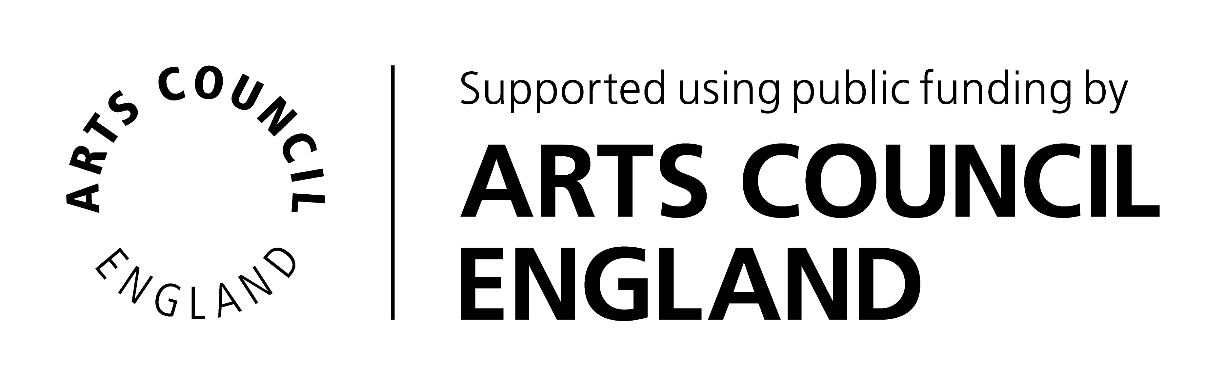

Your contact details

Title (Mr/Miss/Mrs/Ms/Dr/ Other)
First name(s)
Surname
Current occupation
Year of birth
Home Address | Postcode:
Email address
Home telephone number
Mobile telephone number
Preferred method of contact

About you

Please provide a brief outline or any particular skills, interests or experience that you would like to bring to your volunteer role as well as the type of volunteer activity you wish to perform:

How did you hear about volunteering with us?

Special Requirements
If you require any special arrangements to be made to attend an initial induction meeting or if you have any medical conditions you’d like us to take into consideration, please specify those below. This information is requested so that we may care for your needs and will be kept confidential.

Are you applying for a specific, advertised volunteer role? If so, please provide the role title:

Disclosure and Barring Service (DBS) Check

Volunteers applying for roles that involve working closely with children or vulnerable adults on a frequent or intensive basis will be asked to for a DBS check with Enhanced Disclosure (formally known as a CRB check). We will incur any administrative costs involved. If required for your role, would you be prepared to have an Enhanced DBS check? Yes No

Availability

Please give an approximate indication of how often you would like to volunteer:

Once a week Once a fortnight Once a month Other:

Please indicate your general availability:

Weekdays Weekends Mornings Afternoons School Holidays
Other:

Emergency Contact Details

Please give details of your next of kin to contact in case of emergency.

Name
Address | Postcode:
Email address
Daytime tel. number

Referees
Please give contact details of two people (other than relatives or partners) who have known you for more than 2 years who we can contact to comment on your suitability to volunteer for us.

Referee 1  Name |  | Referee 2  Name
Relationship to you |  | Relationship to you
Address | Postcode: | Address | Postcode:
Email address |  | Email address
Telephone |  | Telephone

Privacy Notice
The information you have entered on this form is processed by the Museum of Classical Archaeology only. We use your personal information in order to deliver our contractual obligations to you as a user of our service. We use anonymised data only for reporting, and we do not share your personal data with any third parties or add you to our mailing lists. We use your personal information to contact you about volunteer roles or projects that you have applied for and other related activities.

Please note: if you go on to volunteer with us after expressing your interest, we will ask you to register on the University of Cambridge Museums VolunteerMakers database. This is how we manage our volunteers.

For more information about how we handle your personal information, and your rights under data protection legislation, please see https://www.information-compliance.admin.cam.ac.uk/data-protection/general-data.

I am over 18 years old and I declare that the information I have provided is true:

Signed ........................................................................................... Date ...............................

