Museum of Classical Archaeology
Work Experience Expression of Interest Form

Thank you for your interest in volunteering with the University of Cambridge Museums. Please complete this form and return to: Justyna Ladosz, Museum Education and Outreach Coordinator, Museum of Classical Archaeology, University of Cambridge, Sidgwick Avenue, Cambridge, CB3 9DA or email to jl2141@cam.ac.uk.

In accordance with The University of Cambridge Child and Vulnerable Adult Protection Policy. This opportunity is available to students at school or university aged 16 or over.

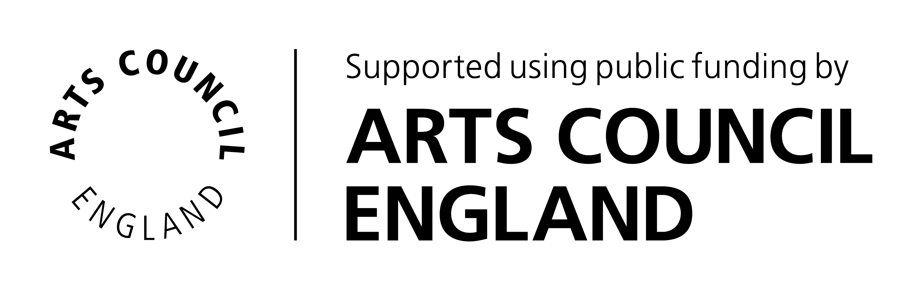


Your contact details

Title (Mr/Miss/Mrs/Ms/Dr/ Other)
First name(s)
Surname
School/University Name
Year of birth
Home Address | Postcode:
Email address
Home telephone number
Mobile telephone number
Preferred method of contact

About you

Please provide a brief outline of any particular skills, interests or experience that you would like to bring to your volunteer role. Please provide a brief outline of any particular skills, interests or experiences that will enable you to carry out this volunteer role well (see Role Description). Please also explain how you will benefit from this placement and what is your motivation in applying for it. (Please aim for 300-500 words).

How did you hear about volunteering with us?

Special Requirements
If you require any special arrangements to be made to attend an initial induction meeting or if you have any medical conditions you’d like us to take into consideration, please specify those below. This information is requested so that we may care for your needs and will be kept confidential.

Availability
Work experience placements will be offered in the period 3rd August – 31st August 2021. Please indicate if you have any preference for dates or if there are dates which would not be possible for you.

Disclosure and Barring Service (DBS) Check

Volunteers applying for roles that involve working closely with children or vulnerable adults on a frequent or intensive basis will be asked to for a DBS check with Enhanced Disclosure (formally known as a CRB check). We will incur any administrative costs involved. If required for your role, would you be prepared to have an Enhanced DBS check? Yes No

Emergency Contact Details

Please give details of your next of kin to contact in case of emergency.

Name
Address | Postcode:
Email address
Daytime tel. number

Referees
Please give contact details of two people (other than relatives, friends or partners) who have known you for more than 2 years who we can contact to comment on your suitability to volunteer for us.

Referee 1  Name |  | Referee 2  Name
Relationship to you |  | Relationship to you
Address | Postcode: | Address | Postcode:
Email address |  | Email address
Telephone |  | Telephone

Privacy Notice
The information you have entered on this form is processed by the Museum of Classical Archaeology only. We use your personal information in order to deliver our contractual obligations to you as a user of our service. We use anonymised data only for reporting, and we do not share your personal data with any third parties or add you to our mailing lists. We use your personal information to contact you about volunteer roles or projects that you have applied for and other related activities.

Please note: if you go on to volunteer with us after expressing your interest, we will ask you to register on the University of Cambridge Museums VolunteerMakers database. This is how we manage our volunteers.

For more information about how we handle your personal information, and your rights under data protection legislation, please see https://www.information-compliance.admin.cam.ac.uk/data-protection/general-data.

I am over 16 years old and I declare that the information I have provided is true:

Signed ........................................................................................... Date ...............................

