A Walk Through the Forum

In Rome, just like the baths, the Forum was a centre for everyday life and business. It was like our marketplaces, but all kinds of people did all sorts of trades and saw their friends in public in the forum.
Today, Julia needs to go to a nearby temple, and passes through the Forum to get there. On her journey, she sees many different people doing their jobs. Can you help us work out what the jobs are in each passage?

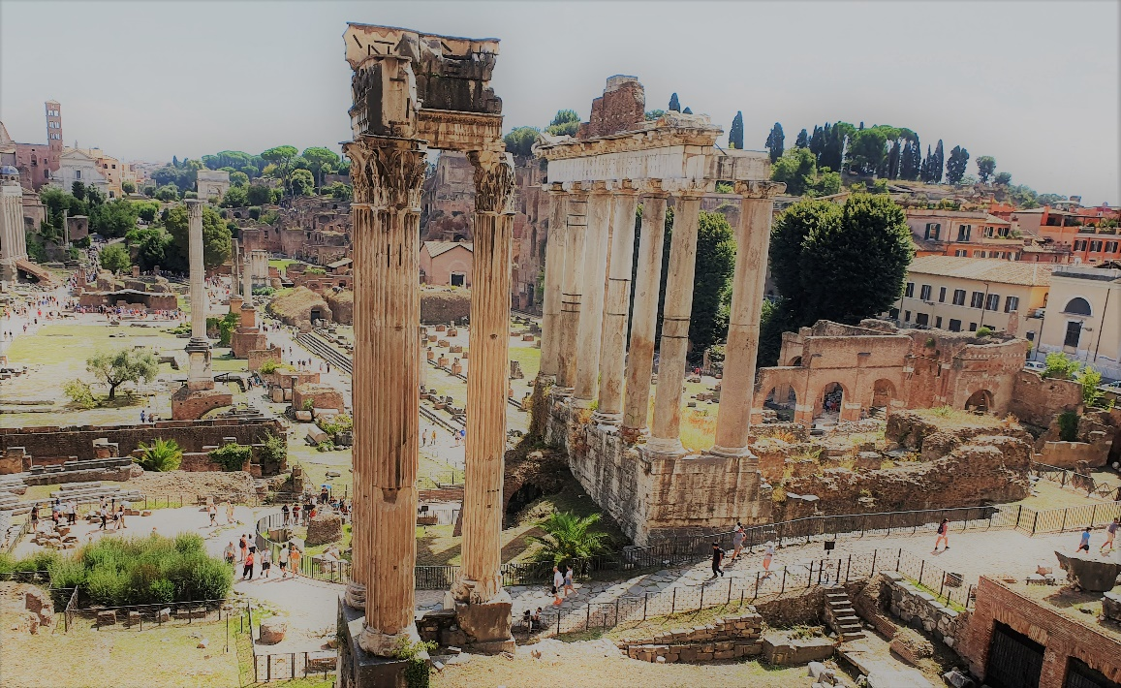

- Julia is excited when she first enters the Forum, because it is full of people. As she walks comfortably along the paved flat ground, carrying her basket, she sees a mercator trying to sell a wooden bowl to one of her neighbours. At a stall next to them, she sees people sat on wooden stools while an ornatrix trims their hair and applies oils to their faces.

- Julia could smell the oils, and she could also smell some of the remedies and herbs that the medicus was applying to an injured person the other side of the path. As Julia keeps walking, the smell is replaced by the smell of warm crusty bread from the nearby stall where the pistor sells his produce.

- There was even more food around the Forum. Julia went to the piscarius to buy a trout for dinner, and pick up some garum* for dinner. She also found that she was getting hungry, so she ate a bowl of stew from a coquus who was making food at his stand. She also picked up an apple from an agricola selling his harvest.
(*garum was a special fish sauce used as a seasoning in Rome, something archaeologists find remains of in storage jars!)
- As she sat under a tree and ate, Julia could see and hear an argument happening nearby. A philosophus, who had been speaking to a crowd about how shapes are not real, was arguing with a magister, who had been teaching some children nearby about shapes and was angry at his suggestion. It got so loud, that a nearby miles had to come over and disperse the crowd before someone got hurt. Julia sighed in relief and stood up, continuing her journey to the temple.

Solutions! (Advanced: with etymology of the noun in quotes)

- mercator= businessman/merchant. (“job that mercat (trades)”)
ornatrix= hairdresser/stylist (“job that ornat (adorns)”)

- medicus= doctor/physician (“person that medicat (treats injury)”)
pistor= baker (“job that pistat (grinds) grains”)

- piscarius= fishmonger (“job to do with fish”)
coquus= cook (“person who coquit (cooks)”)
agricola= farmer (“person who colat (tends) the agri (field)”)

- philosophus= philosopher (“person that philo (loves) sophus (knowledge)”)
magister= teacher (“person that knows magis (more) ter (than others)”)
miles= soldier/guard (the etymology of this is very difficult to work out, which goes to show how it is arguably the oldest job!)

