Adjectives Activity Sheet

Pick an adjective from the list you have learned to describe the people and animals in the little pictures. Make sure you check the ending and ensure you match case, number, and gender! Then translate the sentence into English. The first one is done for you.

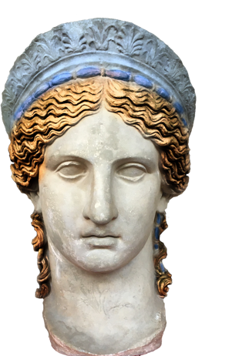 | Antonia garrula est.  (feminine, nominative, singular) | Antonia is talkative.
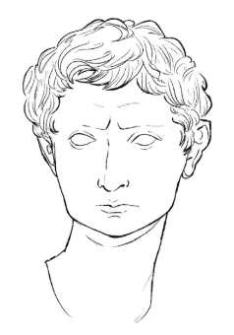 | Augustus* …………….. est.  *Hint: Augustus is considered the first Roman emperor.
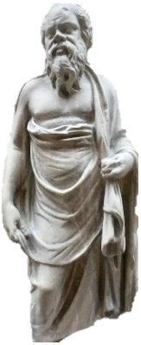 | Socratus* …………. est.  *Hint: Socrates was a famous philosopher famous for the saying “The only true wisdom is in knowing you know nothing.”
Glires* ……..… sunt.

*Hint: this time you need the masculine plural.
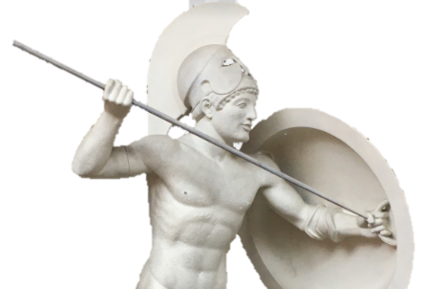 | Miles ……………. est.
Vulpes* …….… sunt.

*Hint: How many foxes are there?
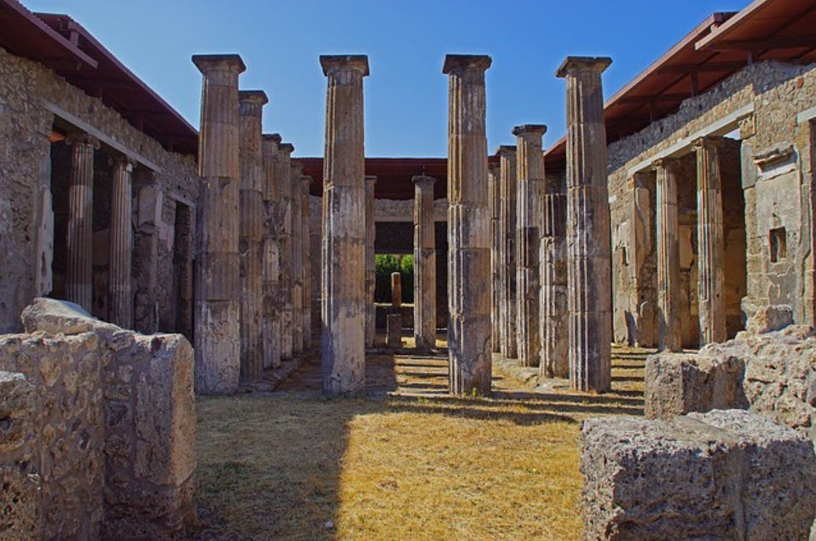 | Templum* …………. Est.  *Hint: Templum is neuter.
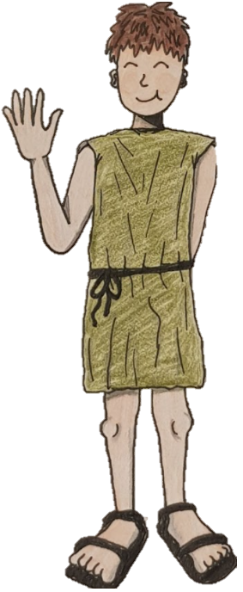 | Lucius amat ……………….. canem*.  *Hint: Cave Canem!! (beware the dog!) What case is ‘canem’ in? Nominative or accusative? You will need to change the ending of the adjective according to the case!

