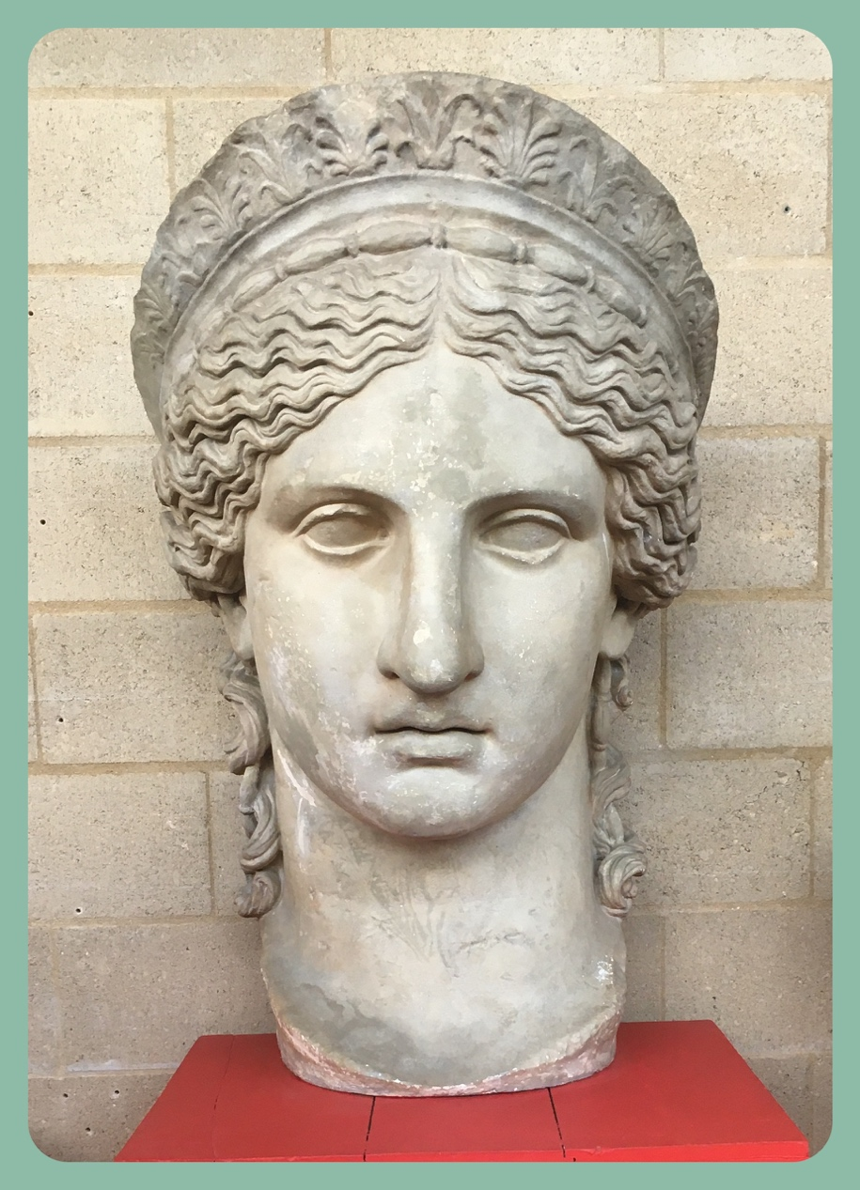
Plan a day in the life of Antonia Minor

Learn about the emperor's family

The Roman Emperor and his family were the most important family in ancient Rome. The women of the family were important role models to all Romans
Antonia Minor was the niece of emperor Augustus. This statue of Antonia in our museum shows her with an elaborate hairstyle. The diadem on her head indicates her role as a priestess.
We know only a few things about her life. Using the facts on the next page, write a plan of the day for Antonia.
Think about
- who helps her get dressed in the morning?
- what gods might she pray to and when?
- who might she visit?
- what does she teach her children?
- what important tasks does she have to do?

Plan a day in the life of Antonia Minor
What we know about her life:

- She had 3 children named Germanicus, Claudius and Livilla. Her husband, Drusus died soon after Livilla was born. Antonia was a widow for the rest of her life.
- She was responsible for looking after the children's education.
- She had a close relationship with Livia, Augustus' wife and her mother-in law. Antonia lived in Livia's house for a long time.
- She was wealthy, and unlike most women had some freedom to spend her money. She lived in Rome, the centre of the Empire.
- She probably had her own slaves, they would help her dress and make her hair.
- Her son Germanicus and daughter Livilla died while she was still alive. Her younger son Claudius became emperor after her death.

Plan a day in the life of Antonia Minor
Schedule Template
You could draw
and write your plan like this.
Or you could plan by hour.
Remember to decorate!

Morning | Afternoon | Evening

