Food Vocabulary

Today you will learn some Latin nouns and verbs that relate to food. For the nouns, the nominative and accusative are listed. For the verbs, the infinitive and first person singular forms for the present tense are given. Along the way, there are some simple sentences to practice your knowledge! Have a go at writing them out. Don’t worry if you get stuck - the answers are at the end of this resource.

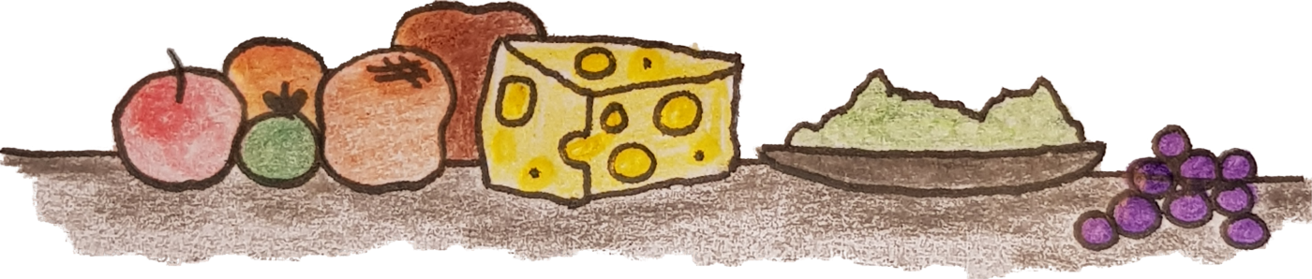
Food
cibus (nominative) cibum (accusative)

Translate ‘Lucius loves food’:
____________________

Apple

malum (nominative) malum (accusative)
N.B. This is a neuter noun so the plural form of both the nominative and accusative is mala.
How would you say: ‘horses love apples’ in Latin?
____________________

Bread
panis (nominative) panem (accusative)

Baker 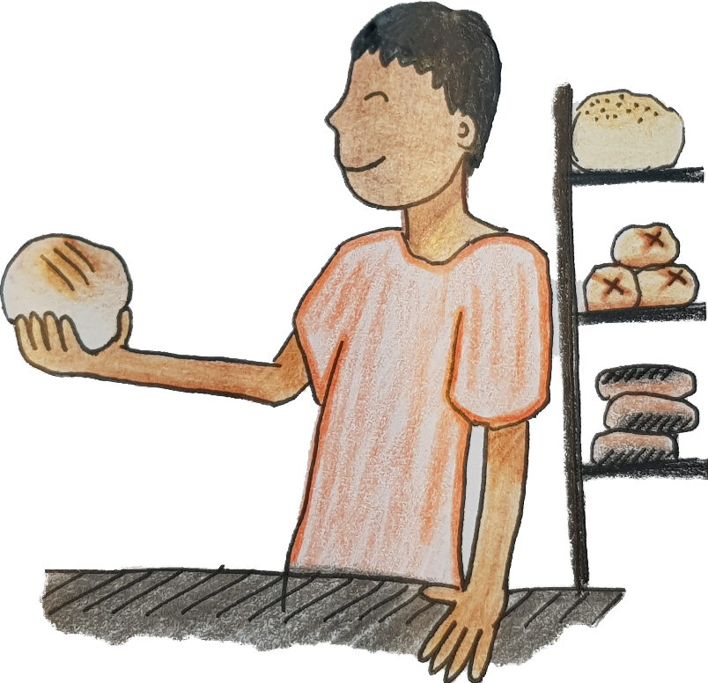
pistor (nominative) pistorem (accusative)

Beetroot
beta (nominative)
betam (accusative)
Eggs
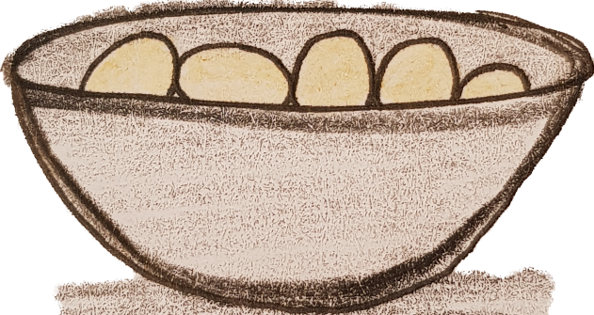
This is a neuter noun in Latin, so the nominative and accusative are the same: ovum in the singular and ova in the plural.

Cheese

caseus (nominative) caseum (accusative)

Fish

piscis (nominative) piscem (accusative)

Dormouse
glis (nominative) glirem (accusative)

Meat

carnis (nominative) carnem (accusative)

Vegetable
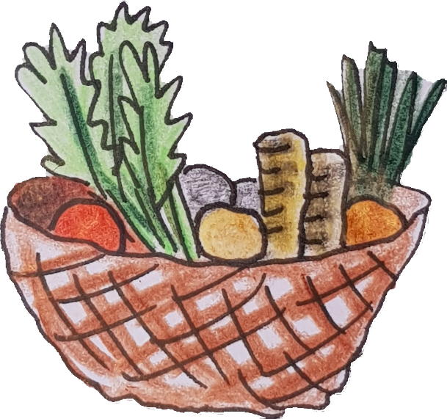
holus (nominative and accusative singular)
holera (nominative and accusative plural)
This is a neuter noun.

Fruit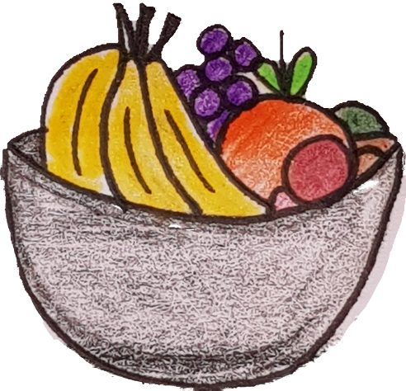
This is a special noun. The nominative singular is fructus, the nominative plural is also fructus. The accusative singular is fructum and the accusative plural is fructus.

Table
mensa (nominative) mensam (accusative)

Grapes 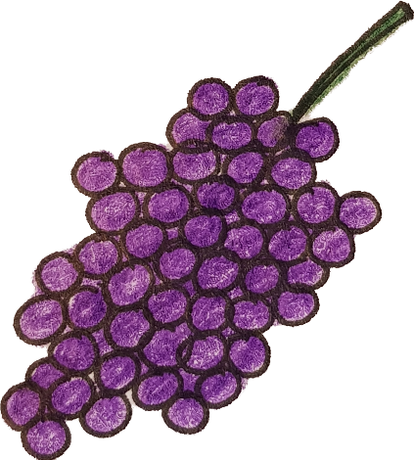
uvae (nominative plural) uvas (accusative plural)
One grape is uva (nominative) and uvam (accusative).

Honey
mel (nominative and accusative)
This is a neuter noun.

Wine
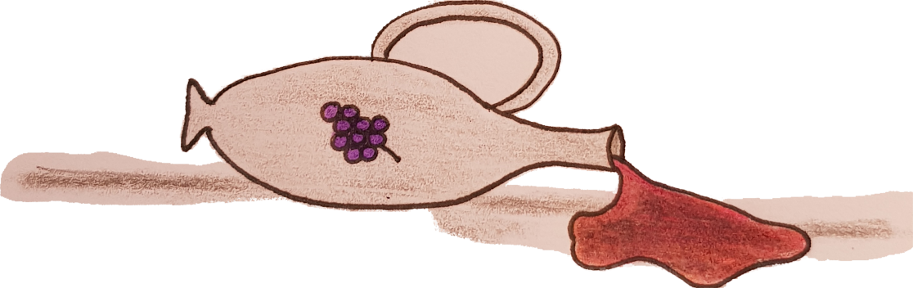
vinum (nominative and accusative)
This is a neuter noun.

Pepper
piper (nominative and accusative)
This is a neuter noun.

How would you say ‘We have honey and cheese’?
____________________
Salt
sal (nominative) salem (accusative)

Garum

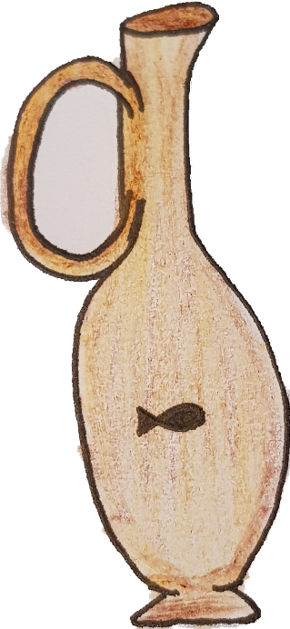
You will learn about this Ancient Roman sauce in another resource this week. It is a neuter noun so the nominative and accusative forms are both garum.
Water
aqua (nominative) aquam (accusative)

Milk
This is a neuter noun. The nominative and accusative forms are both lac.

Breakfast
ientaculum (neuter noun)
Lunch
prandium (neuter noun)

Dinner
cena (nominative) cenam (accusative)

Fishmonger
piscarius (nominative), piscarium (accusative)

Butcher
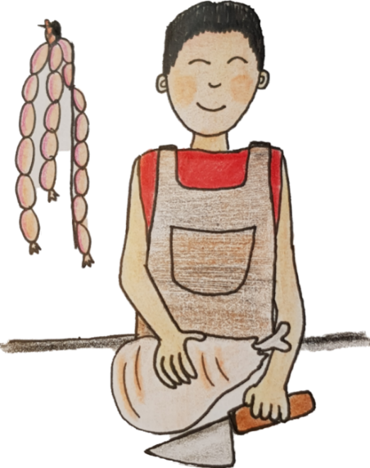
lanius (nominative), lanium (accusative)
‘I cut’ is seco ‘To cut’ is secare
How would a Roman say: ‘Butchers cut meat’?
_______________
Can you remember how to write ‘I love honey and grapes’ in Latin?
_______________

Cook
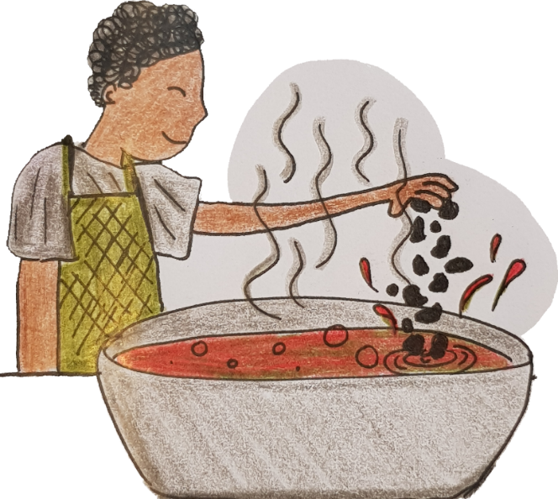
coquus (nominative) coquum (accusative)
‘I prepare’ is paro ‘To prepare’ is parare
Write the Latin for: ‘You are* a cook and you prepare dinner’.
___________________
* ‘You are’ = es
‘I mix’ is misceo ‘To mix’ is miscere
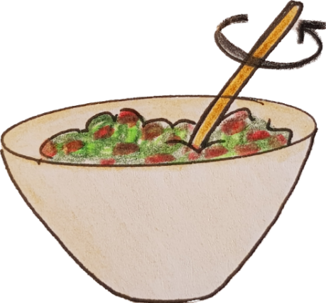
Write the Latin for: ‘They cut beetroot and fish. She mixes eggs, salt, and pepper .’
___________________________________

‘I bite’ is mordeo ‘To bite’ is mordere
‘I taste’ is gusto ‘To taste’ is gustare
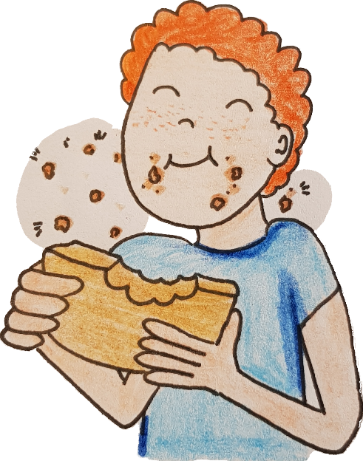
Answers

Lucius loves food = Lucius amat cibum.

Horses love apples = Equi amant mala.

We have wine and cheese = Habemus vinum et caseum.

Butchers cut meat = Lanii secant carnem.

I love honey and grapes = Amo mel et uvas.

You are a cook and you prepare dinner = Es coquus et paras cenam.

They cut beetroot and fish. She mixes eggs, salt, and pepper = Secant betam et piscem. Miscet ova, salem, et piper.

