Describing the world: Latin adjectives

An adjective is a word used to describe a noun and tell us more about its characteristics.
For example, in the English sentence “I love my kind sister”, “kind” is an adjective because it tells us what how the “sister” is!

In Latin, it would sound like:
Amo meam bonam sororem
Et tu bonus es! (= you are kind, too!)
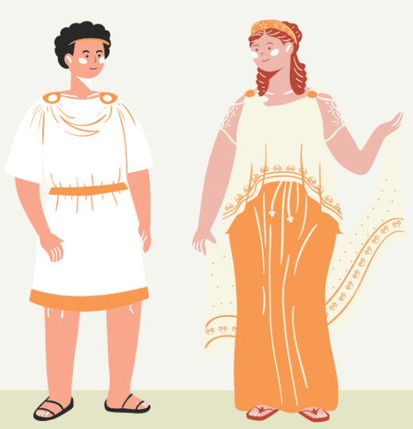

We can already notice two peculiarities:
- Bonam is an accusative, which (as you have studied two weeks ago) is the case of the object. As you can see, it is the same case as the name it is describing (“sororem”).
- Bonam is also feminine and singular, once again just like “sororem” is.
What does this mean?
It means that in Latin nouns and adjectives are best friends, and for this reason they always want to be alike: same case, same gender and same number!
For this reason, adjectives in Latin need to have all genders (masculine, feminine and neutral) and all numbers (singular and plural) to be ready and adapt with any noun they accompany!

Now, let’s look at some useful adjectives! We will give you all genders and numbers for the nominative and the accusative, so you will be able to use them in many, many sentences!
How to read it:
- first line: nominative masculine, nominative feminine, nominative neuter (all singular)
- second line: accusative masculine, accusative feminine, accusative neuter (all singular)
- third line: nominative masculine, nominative feminine, nominative neuter (all plural)
- fourth line: accusative masculine, accusative feminine, accusative neuter (all plural)

- Pulcher, pulchra, pulchrum
Pulchrum, pulchram, pulchrum
Pulchri, pulchrae, pulchra
Pulchros, pulchras, pulchra
(it means “beautiful”)

- Turpis, turpis, turpe
Turpem, turpem, turpe
Turpes, turpes, turpia
Turpes, turpes, turpia
(it means “ugly”)

- Fortis, fortis, forte
Fortem, fortem, forte
Fortes, fortes, fortia
Fortes, fortes, fortia
(it means “strong”)

- Debilis, debilis, debile
Debilem, debilem, debile
Debiles, debiles, debilia
Debiles, debiles, debilia
(it means “weak”)
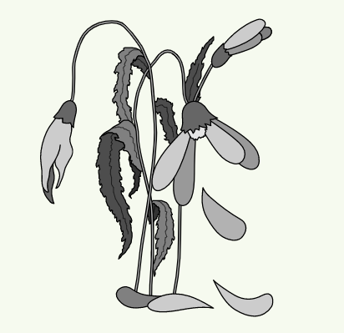

- Magnus, magna, magnum
Magnum, magnam, magnum
Magni, magnae, magna,
Magnos, magnas, magna
(it means “big”)

- Parvus, parva, parvum
Parvum, parvam, parvum
Parvi, parvae, parva
Parvos, parvas, parva
(it means “small”)

- Vetus, vetus, vetus
Veterem, veterem, vetus
Veteres, veteres, vetera
Veteres, veteres, vetera
(it means “old”)

- Novus, nova, novum
Novum, novam, novum
Novi, novae, nova
Novos, novas, nova
(it means “new”)

- Callidus, callida, callidum
Callidum, callidam, callidum
Callidi, callidae, callida
Callidos, callidas, callida
(it means “intelligent”)

It is a lot of stuff to remember but don’t worry, you’ve got this!
Now head to our activities to check what you’ve learned!

