LUCIUS' FARM
Let’s find out how to name the colours of the animals in Latin!

On the next page there will be a ‘vocabulary list’ of colours in Latin to look at while completing the exercise.

The exercise:

Below you will see some photos of animals and you will have to complete the sentence in Latin with the colour of the animal.

Please see the attached document for the answer key.

Vocabulary List

Pink = Rubicundus

Yellow = flavus

Red = ruber

Brown = fulvus

Gray = cinereus

White = albus

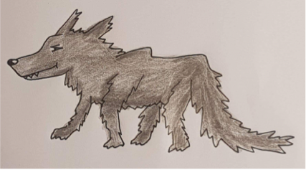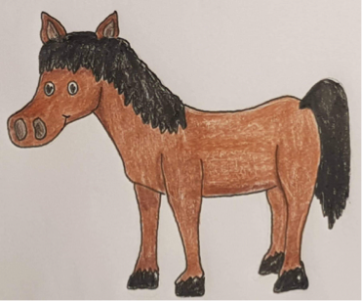

lupus est

equus est

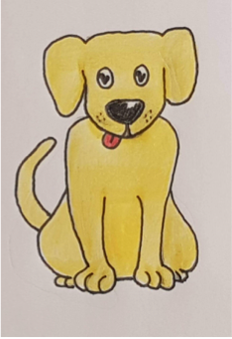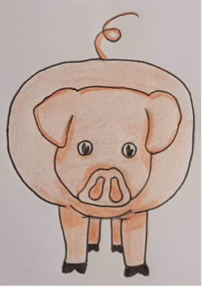canis est

porcus est

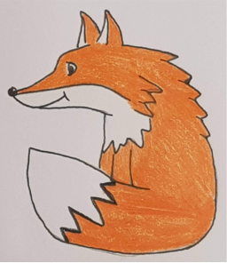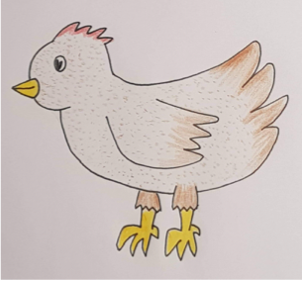
pullus est

vulpus est

et (and)

