Present tense verbs with Lucius part 2!
Table Of Contents
Present tense verbs with Lucius part 2! 1
‘A’ Verbs 2
Phew! Got all that? 4
‘A’ Verbs practice 5
‘E’ Verbs 6
‘E’ Verbs practice 8
‘I’ Verbs 9
‘I’ Verbs practice 11

Now, we’re going to learn more verbs in Latin!
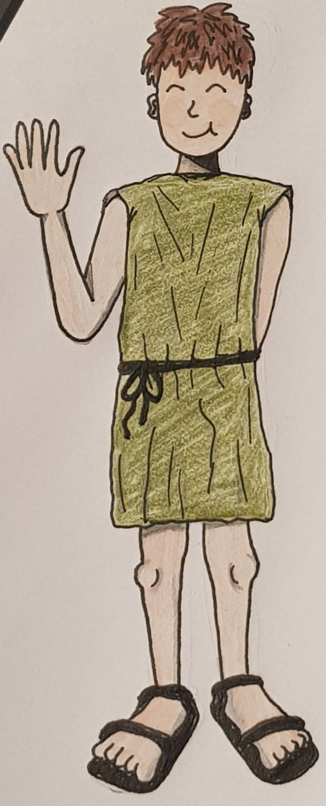
We will learn how to make 3 different types of verb:
          - ‘A’ Verbs
          - ‘E’ Verbs
          - ‘I’ Verbs
By the end you’ll be able to say:
- We sit
- They sleep
- You stand
And much more
In Latin!

‘A’ Verbs

Do you remember in week 2 when we learnt how to say latro (I bark) and amat (he likes)?
Latro!

He likes to bark!=Amat latrare

Well, these two verbs amare (to like) and latrare (to bark) are ‘A’ verbs because the letter before the -re at the end is an a

If we know how to say I like and He likes, how can we say You like, We like and They like?

We need to do more maths! If to say I like we take amare, remove the -are and add o, giving us amo, we do the same to say you like, but instead of o we add as.
So, to say you like, we say: amas!!!
Things like o, as, and at that we add onto the end of verbs are called endings

I, You, She/He/It, We and They all have different endings. These are:
- For I, we add o, so I like is amo
- For You (when talking to 1 person), we add as, so You like (r.e.1 person) is amas
- For She/he/it, we add at, so She/he/it likes is amat
- For We, we add amus, so We like is amamus
- For You (when talking to more than 1 person), we add atis, so You like (more than 1 person) is amatis
- For They, we add ant, so They like is amant

Phew! Got all that?
There are lots of ‘A’ verbs, not just amare and latrare. Here are some more:
Vocare – to call | Notare – to write/to note
Ambulare – to walk | Stare – to stand
Habitare – to live | Spectare – to watch
Lavare – to wash | Laborare – to work

So, if Lucius sees 2 pigs, and wants to say They stand he says:
Stant!

If the pigs see Lucius and want to tell him we stand they would say:
Stamus

‘A’ Verbs practice
Let’s try practicing our endings on these verbs!
(Remember, to make a verb you just take away the -are and add an ending!)

How would you say:
- 1. They watch:
- 2. He works:
- 3. We write:
- 4. You (more than 1 person) wash:
- 5. He lives:

‘E’ Verbs
‘E’ verbs work in exactly the same way as ‘A’ verbs, except rather than ending in -are, they end in -ere. If we take away the -re, then we have an e, making these ‘E’ verbs

Here are some examples of ‘E’ verbs:
Sedere – to sit | Videre – to see
Docere – to teach | Habere – to have
Movere – to move | Iacere – to lie down

We make ‘E’ verbs in the same way as ‘A’ verbs. Just like ‘A’ verbs, we take away the final 3 letters, in this case -ere, and then add endings. However, ‘E’ verbs have different endings to ‘A’ verbs. We will find out what these are on the next page!

- For I, we have eo (instead of o). So, Sedeo means I sit
- For You (1 person), we have es (instead of as). So, Sedes means You (1 person) sit
- For She/he/it, we have et (instead of at). So, Sedet means She/he/it sits
- For We, we have emus (instead of amus). So, Sedemus means We sit
- For You (more than 1 person), we have etis (instead of atis). So, Sedetis means You (more than 1 person) sit
- For They, we have ent (instead of ant). So, Sedent means They sit

So, if Lucius sees 2 foxes and wants to say to them You are sitting, he would say:
Sedetis!

‘E’ Verbs practice
Let’s try practicing our endings on the verbs above!
(Remember, to make a verb you just take away the -re and add an ‘E’ verb ending!)

How would you say:
- 1. She teaches:
- 2. They move:
- 3. We see:
- 4. You (1 person) have:
- 5. I lie down:

‘I’ Verbs
‘I’ verbs work in the same way as ‘A’ and ‘E’ verbs, except rather than ending in -ere, they end in -ire. If we take away the -re, then we have an i, making these ‘I’ verbs
Here are some examples of ‘I’ verbs:
Dormire – to sleep | Audire – to hear
Pervenire – to arrive | Venire – to come

We make ‘I’ verbs in the same way as ‘E’ and ‘A’ verbs. Just like ‘A’ and ‘E’ verbs, we take away the final 3 letters, in this case -ire, and then add endings. However, ‘I’ verbs have different endings to ‘A’ and ‘E’ verbs. We will find out what these are on the next page!

(Bonus phrase: To say I cook, we say facio cenam! Cenam is the accusative singular of cena which means meal, and facio means I do/ I make. So, facio cenam means I make a meal or I cook)
- For I, we have io (instead of o or eo). So, Dormio means I sleep
- For You (1 person), we have is (instead of as or es). So, Dormis means You (1 person) sleep
- For She/he/it, we have it (instead of at or et). So, Dormit means She/he/it sleeps
- For We, we have imus (instead of amus or emus). So, Dormimus means We sleep
- For You (more than 1 person), we have itis (instead of atis or etis). So, Dormitis means You (more than 1 person) sleep
- For They, we have iunt (instead of ant or ent). So, Dormiunt means They sleep

So, if a sheep sees Lucius sleeping and wants to say He sleeps, it would say:
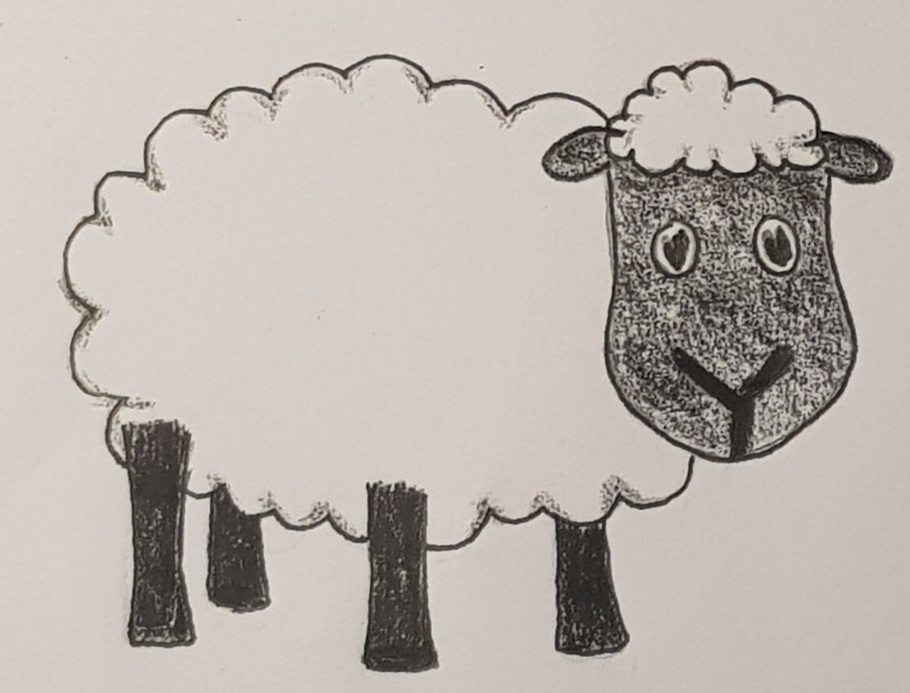
Dormit!
Zzzzz-issimus

‘I’ Verbs practice
Let’s try practicing our endings on the verbs above!
(Remember, to make a verb you just take away the -re and add an ‘I’ verb ending!)

How would you say:
- 1. We come:
- 2. They hear:
- 3. She sleeps:
- 4. I arrive:
- 5. You (more than 1 person) cook:

