Roman Male Noble Names

Roman male noble names had three parts, so many called the naming system:
tria nomina
“three names”
You can see this in the fact that many romans have three distinct names, such as Gnaeus Pompeiius Magnus below

These three names included:
praenomen
“forename”
This is like an English “first name” A noble family often chose a few praenomina that they would use for all the members of the family. A son often had the same praenomen as his father or male ancestors, and a daughter often had the same as their mother or ancestors.
nomen
“name”
This is like an English “last name”. It showed that a Roman was a member of a family.
cognomen
“with-name”
We do not have these in English, but we do something like it when we call somebody “Alexander the Great”. You can think of it like an extra name that some people got with their other names for being good at something, or having something unique.
Many cognomina ended up being part of the family name so noble families could inherit status. Some cognomina came from winning a war, so their “with-name” became the name of the place they won the war e.g. Scipio Africanus”. Some came from characteristics, like having a beard e.g. “Lucius Cornelius Scipio Barbatus”

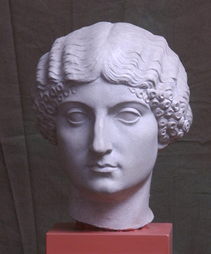
Roman Female Noble Names
The way Roman female names were made changed sometimes in Rome’s history. But there was a pretty standard way.
To begin with, women were named in the feminine form of their family name, the “nomen”. They kept this even when they were married.
If her father’s “nomen” was “Claudius”, she would be called “Claudia”. This was the only name many noble women went by
Many eventually had a name that meant they belonged to their husband’s family by taking their name in the possessive case: e.g. if Claudia married a Metellus, she would be Claudia Metelli.
Later in time, women also started to take on the “cognomen” of her father, also in the feminine form.
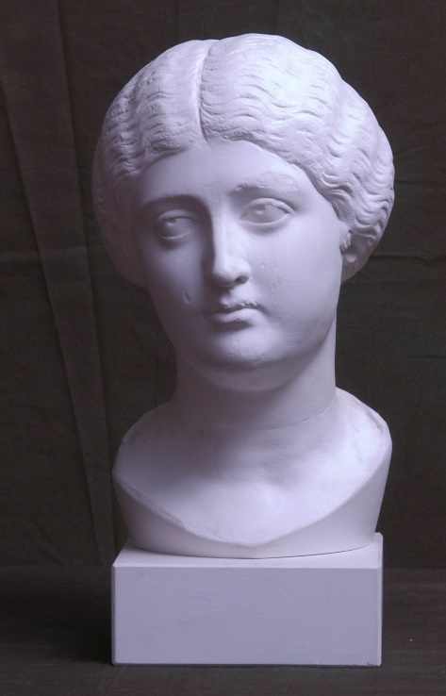
The daughter of “Marcus Licinius Crassus” took the feminine forms of the last two names, to become “Licinia Crassa”
They would often use other terms to make sisters have different names.
If the daughter had a little sister, the daughter would be “Licinia Crassa Maior”, and her little sister would be “Licinia Crassa Minor”.
If the daughter was the sixth child, she would be “Licinia Crassa Sexta”.
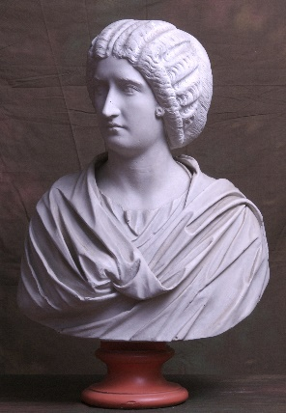
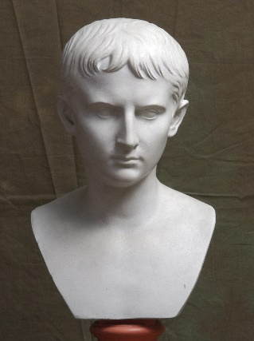
Short Exercise

With each name, work out if the person has a male or female name and highlight it in colour.

- Gnaeus Pompeiius Magnus

- Julia Augusta
- Livia Drusilla

- Publius Clodius Pulcher

- Lucius Cornelius Scipio Asiaticus

- Lucretia

- Gaius Marius

- Tarquinia

- Publius Cornelius Scipio Africanus

- Atia Balba Caesonia

Answers:
- Male
- Female
- Female
- Male
- Male
- Female
- Male
- Female
- Male
- Female

