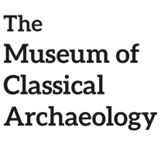 Welcome to the Thermae!

Salvete, everyone! After a long week of grammar rules and revision, why don’t you take a break in our magnificent thermae, the public baths?

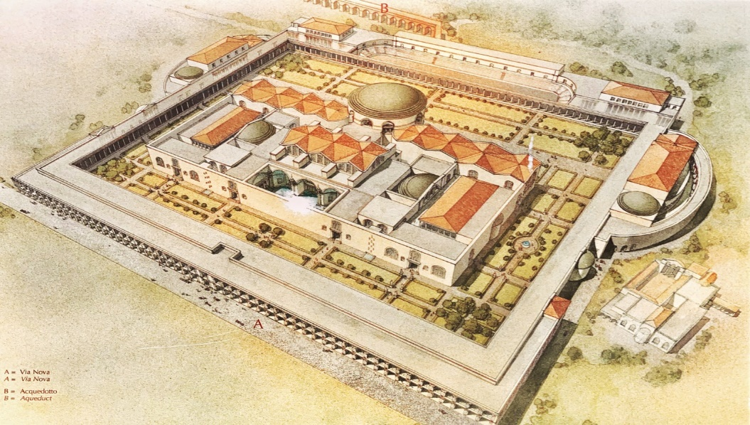
Figure 1: Baths of Caracalla (source: https://www.romewise.com/baths-of-caracalla.html)
We will discover together all the different parts of the thermae, and don’t worry about the entrance ticket: everyone loved the thermae, so the price was very low!

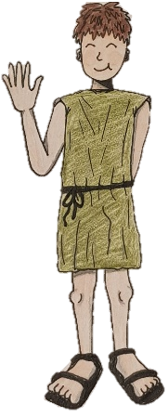 Look: it’s Lucius! Like every good Roman, he really likes to go to the thermae to relax, swim, exercise and talk with his friends.
Salve, sodale! (= friend)
He is going to give you a nice tour, so we can learn all about them!

The layout of the thermae

Public and private thermae were everywhere in Rome and in the whole Empire, so they could be very different from one another. However, there are tres principal rooms found in every thermae:

- The tepidarium
Its name means “warm room”, because tepidum est (= it is warm)!
It was a large decorated room filled with warm air, with a lot of benches where you could sit, relax and have a chat with your friends.
This is where the “bath experience” starts!

- The calidarium:
Its name means “hot room”, because caldus means “hot”! It is very similar to a modern sauna.
This room was built above another room called “hypocaust”, where large numbers of slaves would work to maintain lots of furnaces: from the fire, hot air was produced and sent to the calidarium through pipes. In this way, both the air and the floor of the calidarium were constantly hot. It was such hard and dangerous work for the slaves!

- The frigidarium:
Its name means “cold room”, because frigidus means “cold”, and it was the last step of a typical bath visit: here Romans could cool down after the calidarium and swim in a swimming pool of cold water.
Fun fact: most Romans didn’t know how to swim, so the pool was very shallow (like a kiddie pool) to avoid accidents!

Special elements

Going to the thermae was truly ana amazing experience for everyone, and it was not just about sweating and swimming about!
Continue our tour to discover all the other things that you can find in the thermae.

- The horti
The horti (the gardens) are a beautiful feature of many baths: why don’t you take a stroll, admire the flowers, the statues, and even the animals that live there!
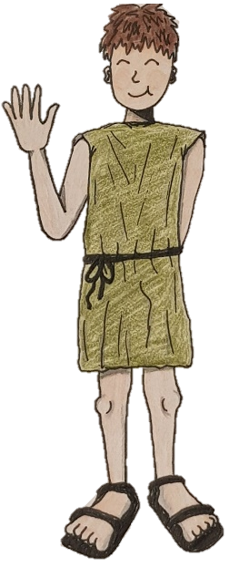
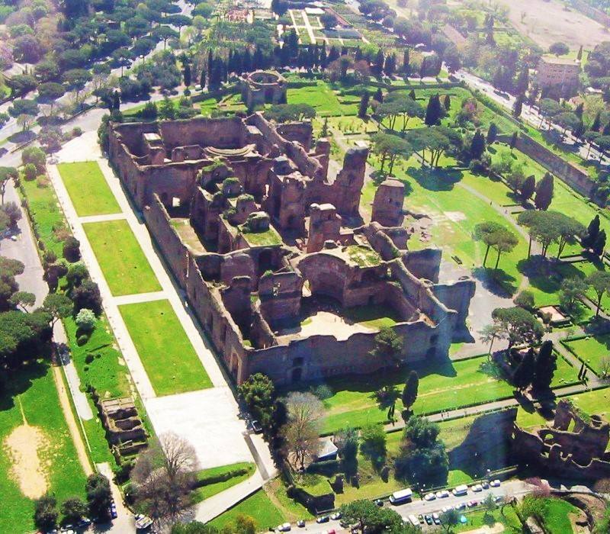
Callidi sunt!
( = they are beautiful)
Figure 2: the gardens of the Thermae of Caracalla (source: https://euroviajar.com/en/baths-of-caracalla-in-rome/)

- The palaestra:
Many baths also had gyms (palaestrae), where men and women could exercise, train and have some fun!
Fun fact: Romans loved to play their version of volleyball!
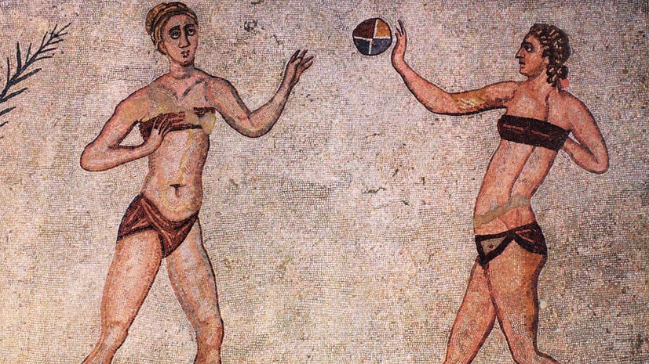
Figure 3: mosaic of Villa Romana del Casale (source: https://discoveritaly.alitalia.com/it/al/destinazioni/catania/villa-romana-casale-piazza-armerina-sicilia)

- The bibliotheca:
There was space for silence and reading, even in the thermae!
The bigger baths could often include libraries, with books and papyri in both Greek and Latin: in fact, many noble Romans were perfectly bilingual.
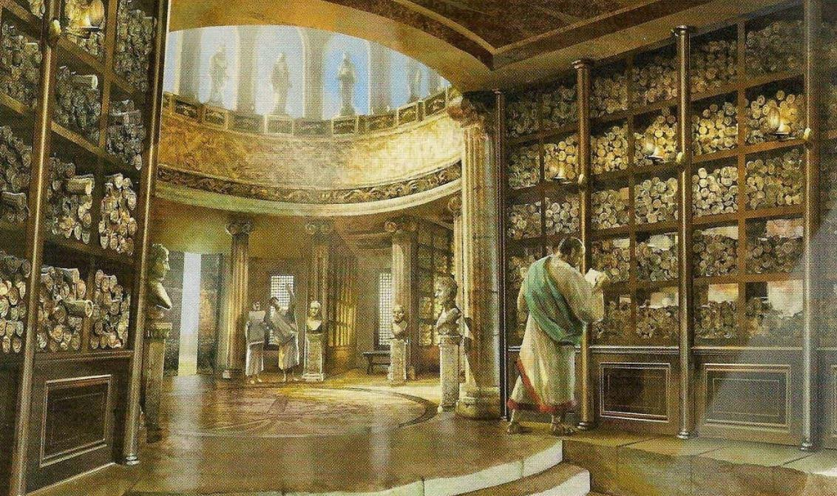
Figure 4: reconstruction of the public library built by Asinius Pollio (source: https://eaglesanddragonspublishing.com/gaius-asinius-pollio-and-the-first-public-library-in-ancient-rome/)

Did you enjoy Lucius’s tour?
We hope that you had fun and that you have learned many new words: go to our activity to see if you remember them!
Vale!!

