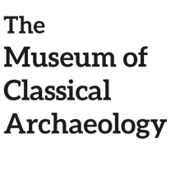
Welcome to the Thermae: exercises!

- Use the clues to find out what part of the Thermae is being described, then write the name (the first letter is provided):

- It means “cold room”
- There is a swimming pool
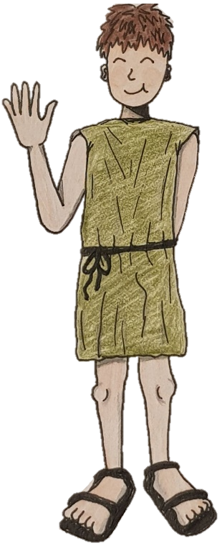
It’s the F _ _ _ _ _ _ _ _ _ _

- It’s full of books in Greek and Latin
- It’s not found in every thermae
It’s the B_ _ _ _ _ _ _ _ _ _

- There are animals and plants
- You can take a stroll there after the baths
They are the H _ _ _ _

- It’s built on top of a hypocaust
- It’s almost like a modern sauna
It’s the C _ _ _ _ _ _ _ _ _

- Romans would play “volleyball” there
- It’s a place to exercise
It’s the P _ _ _ _ _ _ _ _

- It’s the first room in the thermae
- There are benches to sit down and chat with friends
It’s the T _ _ _ _ _ _ _ _ _

- Some light translation! Try and translate these Latin phrases in English. Top tip: some of these words were already used in other activities!

- Lucius amat thermas
(thermas: accusative of thermae)

- Mater est in hortis
(in: same as the English preposition “in”; hortis: comes from horti, in the ablative case, it indicates being in a place)

- Vacca non est in tepidario!

- Callida bibliotheca est ante templum
(ante: in front of)

- Filiae ambulant per palaestram
(per: around)

What follows is the answer sheet: don’t peak! Check only after you’re done with the exercises
- It means “cold room”
- There is a swimming pool
It’s the FRIGIDARIUM

- It’s full of books in Greek and Latin
- It’s not found in every thermae
It’s the BIBLIOTHECA

- There are animals and plants
- You can take a stroll there after the baths
They are the HORTI

- It’s built on top of a hypocaust
- It’s almost like a modern sauna
It’s the CALIDARIUM

- Romans would play “volleyball” there
- It’s a place to exercise
It’s the PALAESTRA

- It’s the first room in the thermae
- There are benches to sit down and chat with friends
It’s the TEPIDARIUM

- Lucius amat thermas = Lucius loves the baths

- Mater est in hortis = The mother is in the gardens

- Vacca non est in tepidario! = The cow is not in the warm room!

- Callida bibliotheca est ante templum = The beautiful library is in front of the temple

- Filiae ambulant per palaestram = The girls walk around the gym

