Writing Latin Sentences 2!

This week, you’ve learnt lots of new words to do with food and cooking. Now we will try to use these words to write some longer sentences in Latin!
We will also be using some of the grammar that you have learnt in previous weeks. This includes:
- ‘A’, ‘E’ and ‘I’ verbs, for I, You, She/He/It, We, You and They
- Masculine, feminine, and neuter nouns in singular and plural and in the nominative and accusative
- Prepositions
We will also be using some of the words you learnt in previous weeks to do with animals, Roman towns, and Roman houses.
That may seem a lot to remember, but don’t worry, each question will come with a clue to help you if there’s something you’ve forgotten! You can also go back to look at previous weeks’ resources to help you.

Example Sentence
Before we get started, Let’s go through an example sentence to see how it’s done!
Lucius comes to the table and prepares to taste the grapes.
To say Lucius comes we need the verb to come which is venire. This is an ‘I’ verb and so the ending for ‘She/He/It’ is -it, so Lucius comes is Lucius venit. (P.S. You can look back at the Present tense verbs with Lucius Part 2 resource from week 4 to remember how to make ‘A’, ‘E’ and ‘I’ verbs)
To say to the table we will use the preposition ad to say to. The word for table is mensa. The prepositions that we know take the accusative, so if mensa is nominative, then the accusative is mensam. So to the table is ad mensam (P.S. You can look back at the Prepositions resource from week 4 if you’ve forgotten how prepositions work)
To say prepares to taste we need the verbs for to prepare and to taste. These are parare and gustare. Parare is an ‘A’ verb and so the ending for ‘She/He/It’ is -at, so he prepares to taste is parat gustare.
The grapes here are the object of the verb because they are being tasted. Therefore, they are in the accusative. They are also plural as we are talking about more than one grape. The word for grape, uva is feminine, so the accusative plural of uva is uvas. Putting these all together we have parat gustare uvas. (P.S. You can look back at the Plurals resource from week 5 if you find making accusative plurals hard)
So, to say this in Latin we write:
Lucius venit ad mensam et parat gustare uvas !!!

Now it’s your turn! Try and translate the following Sentences into Latin!

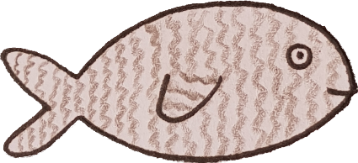
- The fishmongers prepare a fish.
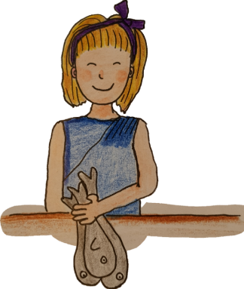

Clue: We need to put fish in the accusative here. The
word for fish has the same accusative ending as words
like glis (dormouse) and ovis (sheep)
Clue: For The fishmongers prepare we need the ‘they’
ending, because we are talking about more than one
fishmonger (see week 4 verbs resource for extra help)

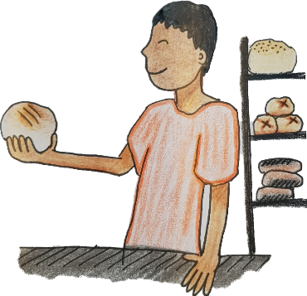
- We like to watch the baker. He cuts the bread.

Clue: Can you remember whether to like is an ‘A’, ‘E’ or
‘I’ verb? Knowing this will help you find the correct ‘we’ ending
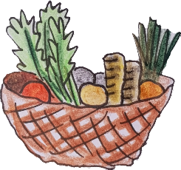
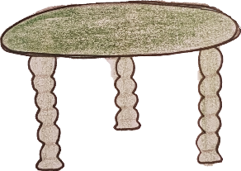
- The vegetable is near the table.

Clue: near is a preposition, so that means we will have to put
table in the accusative. (see week 4 prepositions resource
for extra help)
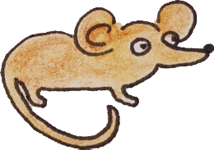
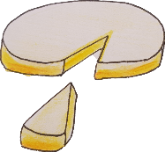
- The dormouse sits outside the dining room and bites cheese.

Clue: Both the verbs here are ‘E’ verbs. Can you remember
what their endings are?
Clue: The Latin word for ‘and’ is et

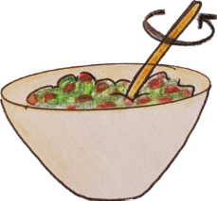
- The cook mixes beetroot, apples, salt, pepper and grapes.

Clue: All of the foods that the cook is mixing are accusative.
Watch out, however, because most of them are singular, but
some others are plural!

- I taste the lunch and the dog sits under the table. He sees the food.

Clue: The first and the second verbs will need different
endings, because ‘I’ am doing the tasting whilst the dog is
doing the sitting.

Bonus exercise!

Here is a short story in Latin. See if you can understand what it means in English!
(Bonus words: The Latin word non means ‘not’ in English,
and the Latin word sed means ‘but’ in English

Glis amat caseum. Glis ambulat ad pistorem, sed non videt caesum! Glis venit ante piscarium et videt pisces, sed non videt caesum! Glis non videt caesum et venit ad domum et dormit. Habitat prope triclinium. Glis audit coquum et movet ad triclinium. Prandium est super mensam et coquus parat caesum. Glis videt et mordet caseum!

