**Roman History: Conquest of Britain**

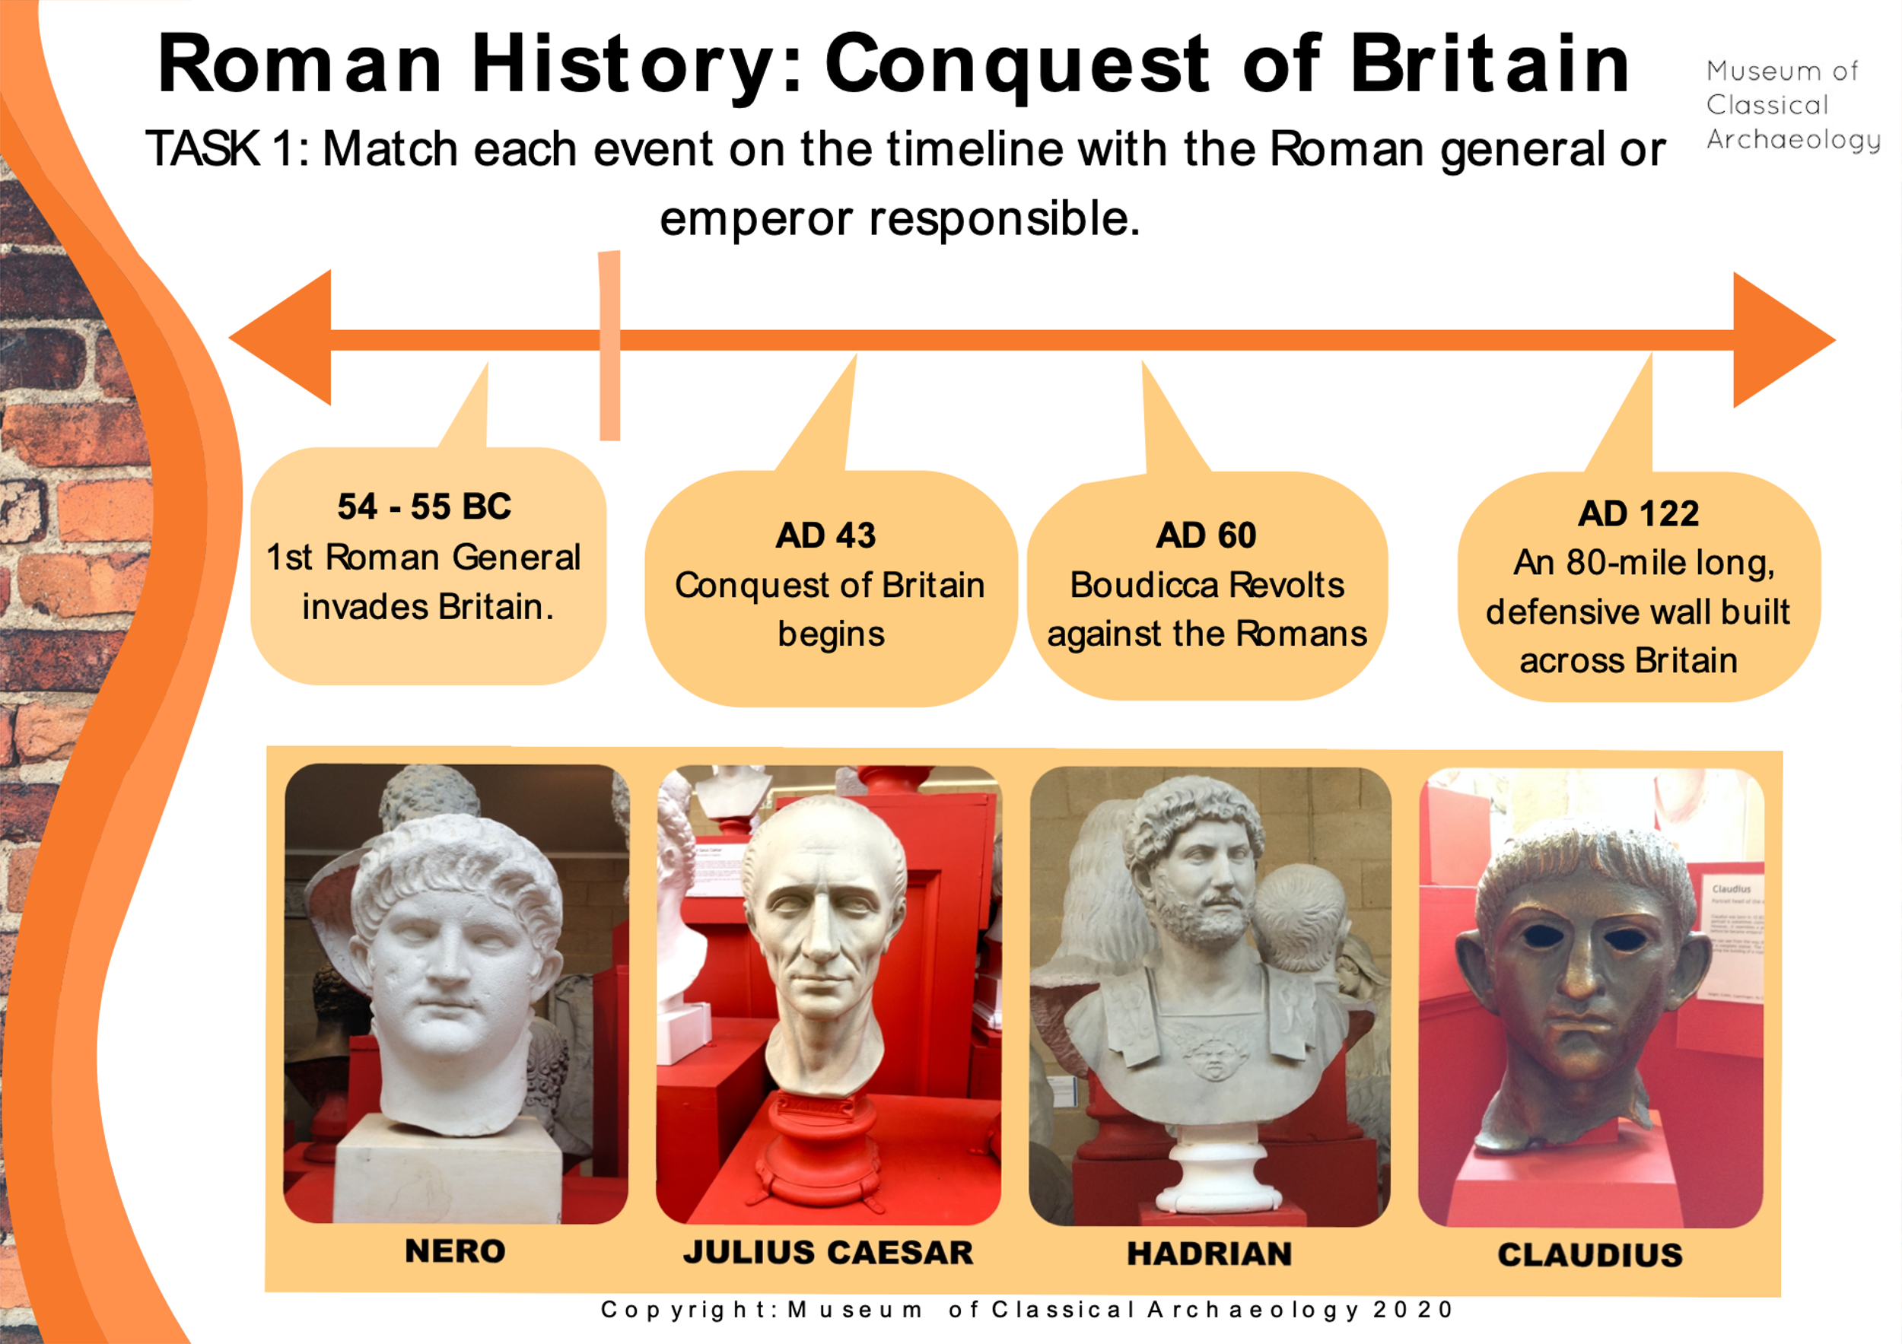

TASK 1: Match each event on the timeline with the Roman general or emperor responsible.

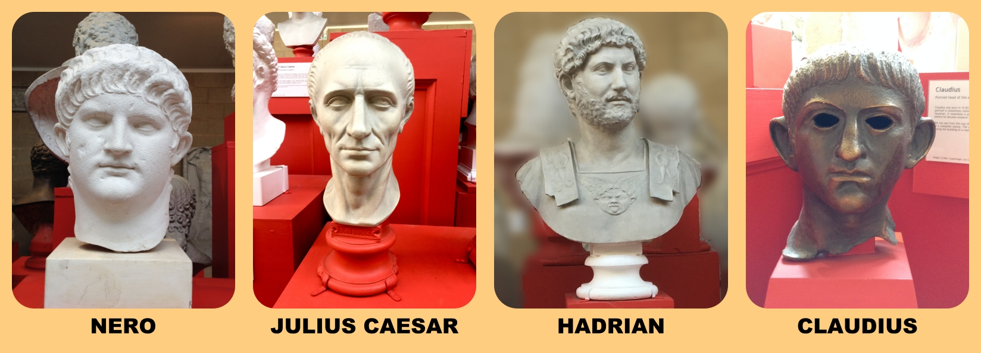

**Roman History: Conquest of Britain**

**The General: Julius Caesar**

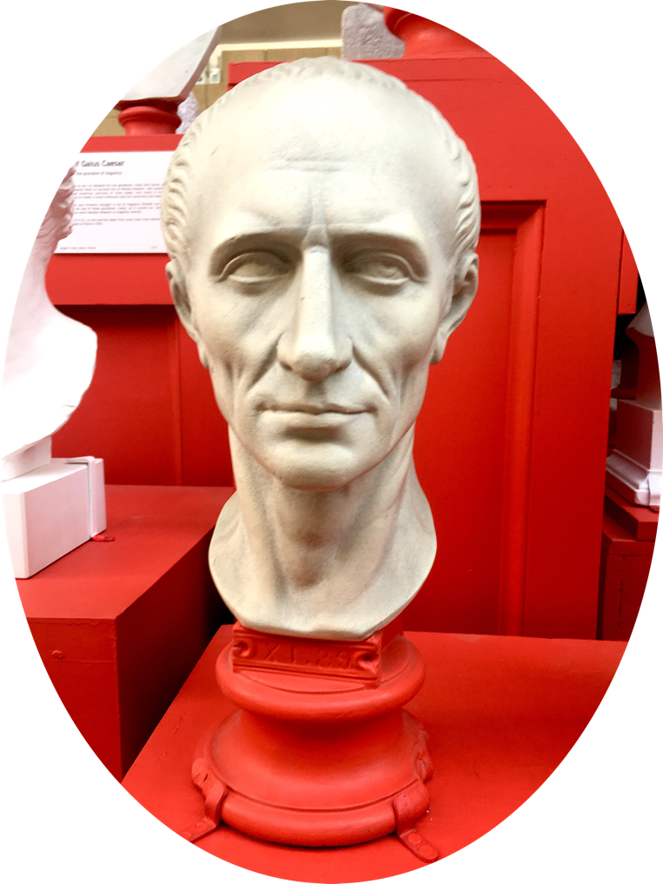

**Julius Caesar**was never an emperor of Rome! But he was a very powerful general, some might even say a dictator. Julius Caesar invaded Britain in 55 BC. He landed on the coast of Kent but many of his ships were wrecked and damaged by a storm!

After a few small battles, he had to turn back to France (Gaul). Caesar returned a year later in 54 BC with more ships and more soldiers. He was slightly more successful this time and established Rome's foothold in **Britain**.

**TASK:**What is the difference between a king, a dictator and an emperor? Discuss and write down at least 3 characteristics of each.

**Roman History: Conquest of Britain**

**The Emperors: Claudius**

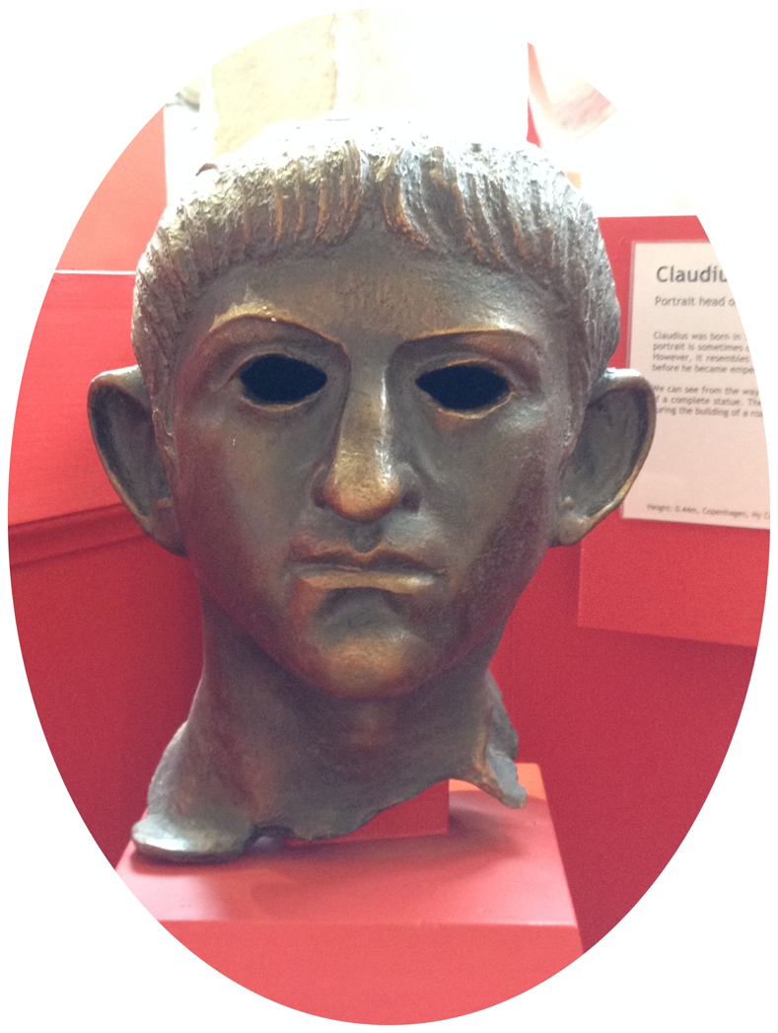

**Claudius** became emperor at the age of 50, after Caligula was assassinated. Before that, many thought he was very foolish and weak. But he claimed it was a survival tactic for living at the imperial court – nobody thought he was a threat.

****He was a bookish character and invented three new letters for the alphabet, but they didn’t catch on. He wanted a military victory and so launched the invasion of **Britain**.

**TASK:**This head was found in a river in Suffolk. The ragged edge means the head was violently cut or snapped from the rest of the statue. What might have happened? When? Why?

**Roman History: Conquest of Britain**

**The Emperors: Nero**

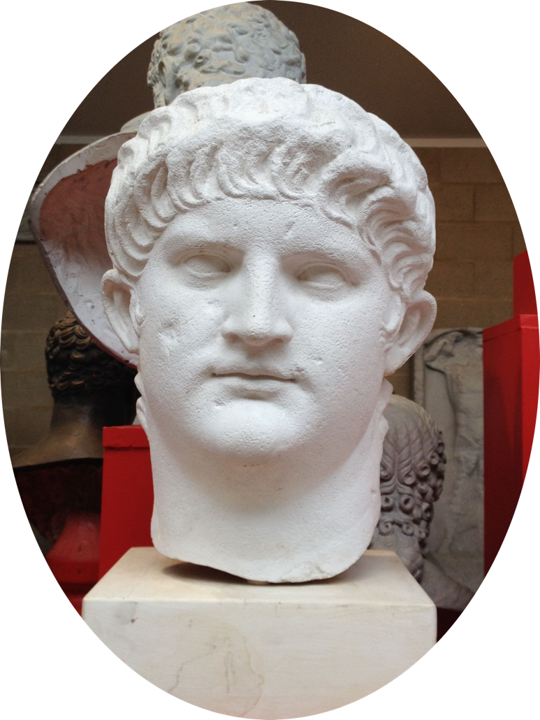

******Nero** became emperor when he was only 17. His statue shows him as young man with downy cheeks: he’s not yet shaved his first beard. He was obsessed with music and loved to perform. To keep his voice in top condition, he would lie on his back with a slab of lead on his chest. He had 5000 young men trained to applaud him when he sang. No one was allowed to leave the theatre during a performance. Some people pretended to be dead so they could **escape!**

**TASK:**Nero had to deal with a revolt in Britain while he was emperor. What are 3 things you would do if you were in charge of a country protesting against you? What would Nero do?

**<?xml version="1.0" encoding="UTF-8"?>**

**<!DOCTYPE imoviexml>**

**Roman History: Conquest of Britain**

**The Emperors: Hadrian**

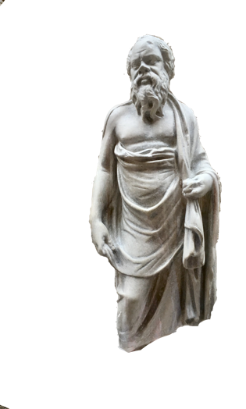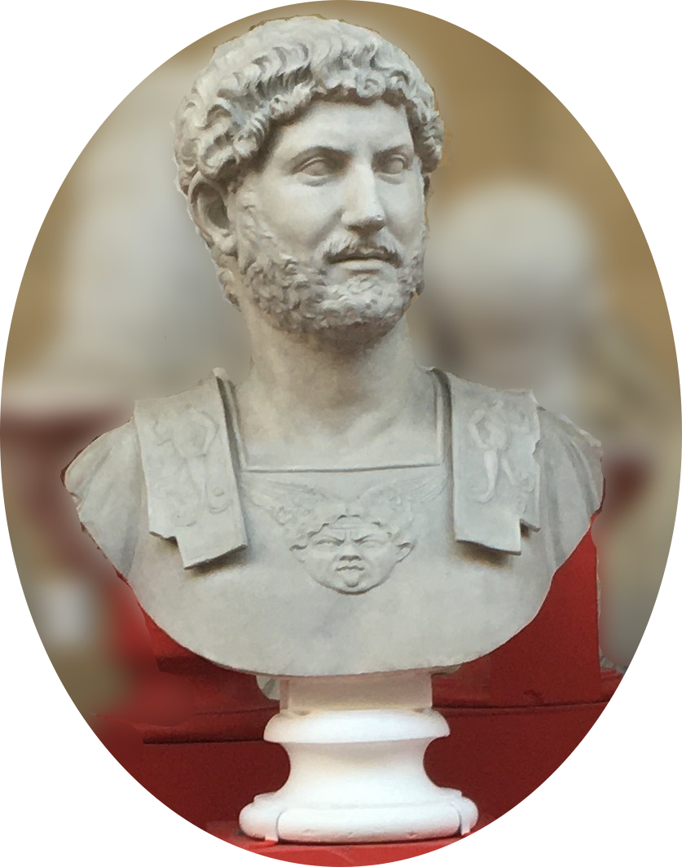**Hadrian** was the first Roman emperor to wear a full beard. As well as fashion this is a sign of how much he prized Greek culture. Many of the Greek politicians and philosophers in the Museum also have beards just like Hadrian. Hadrian spent most of his reign on the move around the different provinces of the Empire. He ordered the building of Hadrian’s Wall. This marked the northernmost limit of the Roman Empire in **Britain.**

**TASK:**Can you see Medusa’s head on Hadrian’s armour? Find out what her story is! Can you think of reasons why Hadrian included her head on his armour?

**Roman History: Conquest of Britain**

You will need:

* A4 paper
* Pencil
* Colouring pens or pencils

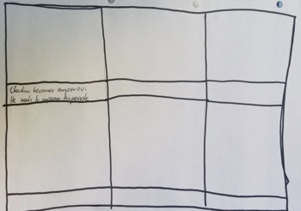**Creative Task: Comic**

**Step 1.** Draw a comic grid like this one

**Instructions:**  Draw a comic about Claudius based on what you learned. We wrote 4 labels that will help you structure the story. You will need to create a label for 2 boxes yourself!

It should have 6 boxes, and space for labels.

**Step 2. Label the boxes:**

**Step 3:** Draw pictures that match the labels!

1. Claudius becomes emperor. He needs to impress his people.
2. Claudius looks for inspiration in his ancestors.
3. He realises he should invade Britain.
4. The Roman army sets out on ships.