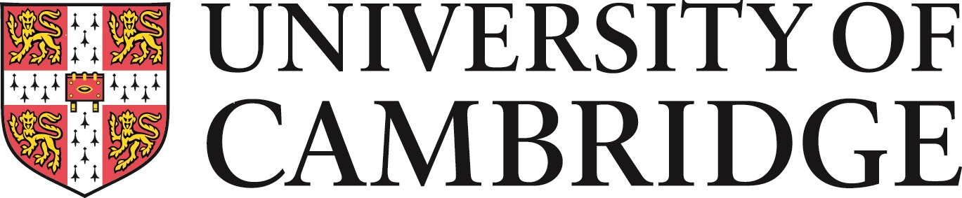

Faculty of Classics

The Craven Seminar, 21-23 May 2020

John Chadwick and the future of Mycenaean Studies

Preliminary programme

Thursday 21 May

3pm-4pm Welcome (coffee and tea available)

4pm Celebratory keynote:
John Killen (Cambridge)
Remembering John Chadwick

5pm Marie Louise Besch Nosch (Copenhagen)
A contribution to the historiography of Michael Ventris' life. His year in Plön, Schleswig Holstein.

5.45 pm Reception in Cast Gallery; Chadwick exhibition display

Friday 22 May

9.30 am Pia de Fidio (Salerno)
The Mycenaean polities at the crossroads between Southern and Near Eastern cultural influences: some suggestions

10.15 am Vassilis Petrakis (Athens)
Texts in context: A first outline of the assemblage of Linear B administrative documents from Ayios Vasileios, Laconia
(presentation based on research carried out by Adamantia Vasilogamvrou and Vassilis Petrakis)

11 am Coffee

11.30 am John Bennet (Athens and Sheffield)
Homer - Pseudo-Historian or Liar? Homer, Linear B and John Chadwick

12.15 pm Yves Duhoux (Louvain)
John Chadwick and the Method in Mycenology

1pm Lunch

2.30 pm Nicole Guilleux (Caen)
From po-ti-ro 'deep-sea pilot' to ποντίλος 'Argonaut, Paper Nautilus' - in the footsteps of Chadwick's lexicographical contribution

3.15 pm Alberto Bernabé (Madrid)
Greek and Mycenaean Lexicography: John Chadwick and beyond

4 pm Tea

4.30 pm Artemis Karnava (Rethymno)
The Minoan Filing System

5.15 pm Lisa Bendall (Oxford)
The masons’ marks from Minoan Knossos

Saturday 23 May

10 am Jörg Weilhartner (Salzburg)
What do we know about Mycenaean religion?" Thoughts on Mycenaean ritual practices

10.45 am Coffee

11 am Concluding keynote:
Cynthia Shelmerdine (Austin)
Shifting Views of Palatial Authority

12 noon 𐀤 𐀫

Contact: tm10012@cam.ac.uk

