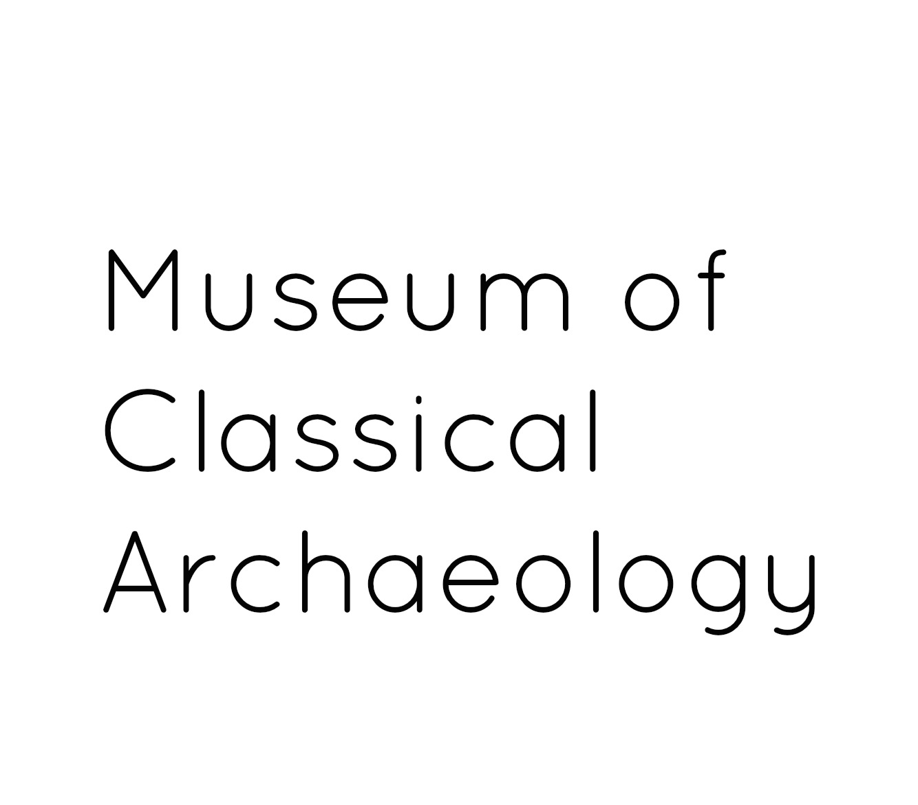
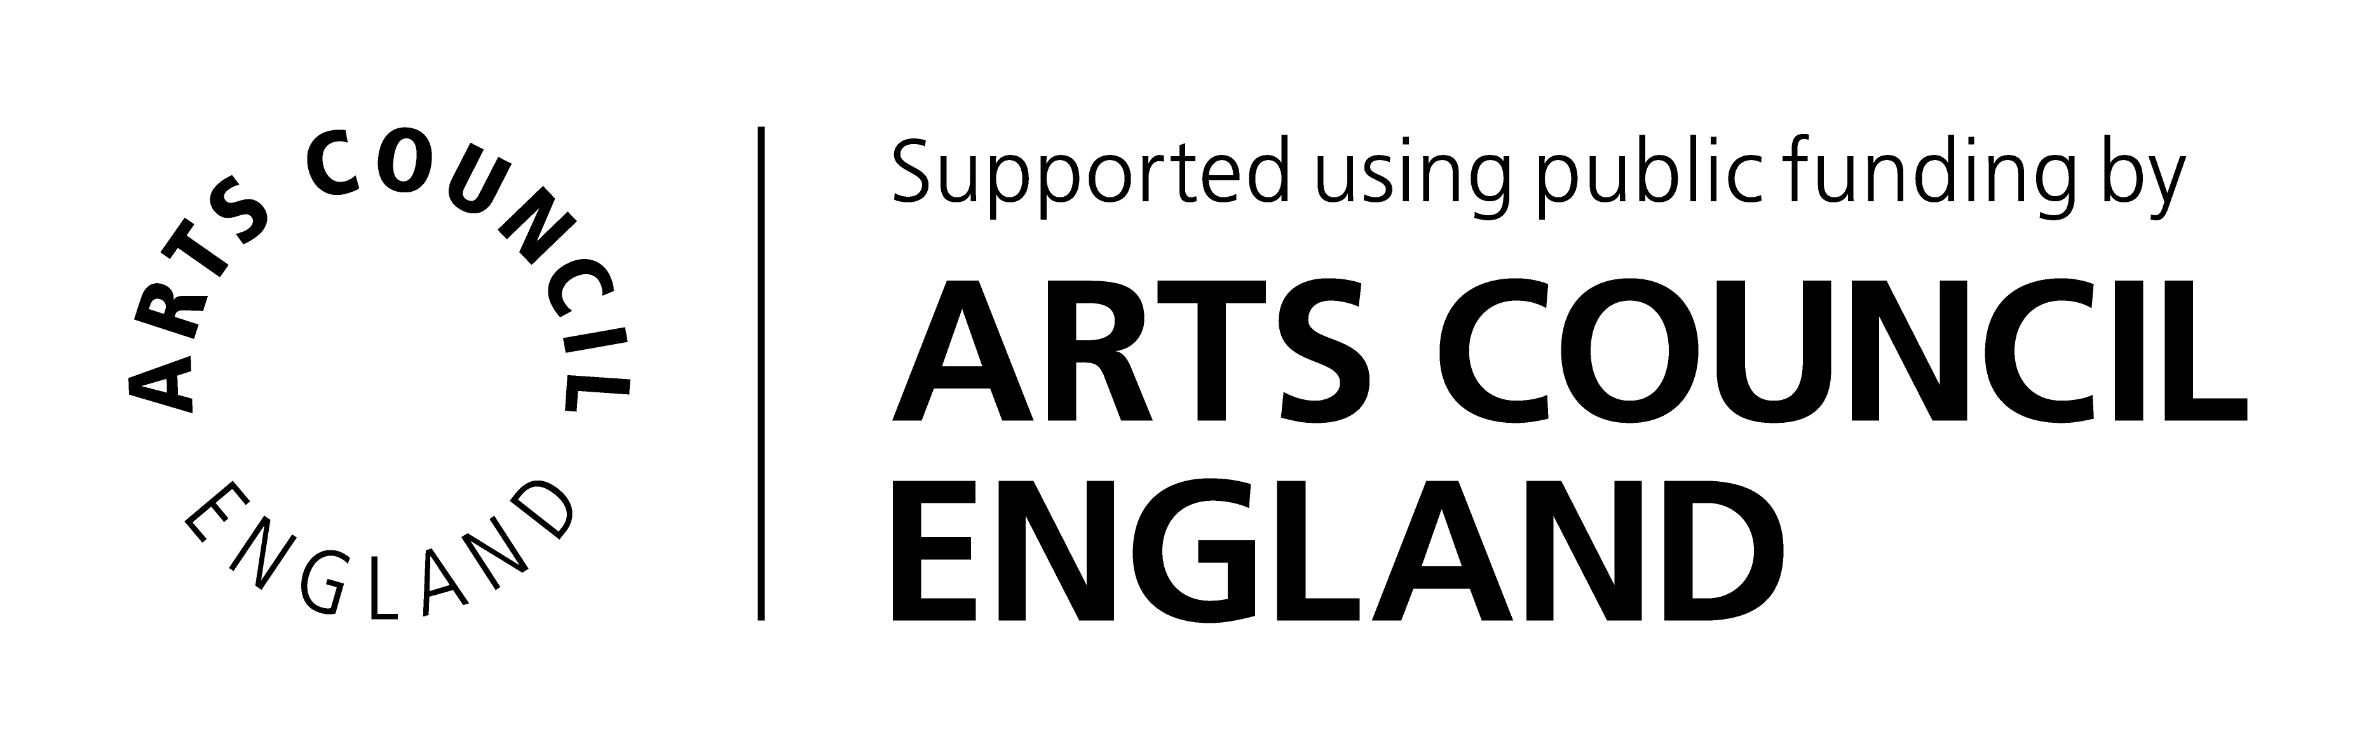

VOLUNTEER EXPRESSION OF INTEREST FORM

Thank you for your interest in volunteering with the University of Cambridge Museums. Please complete this form and return to: Jennie Thornber, Museum Education and Outreach Coordinator, Museum of Classical Archaeology, University of Cambridge, Sidgwick Avenue, Cambridge, CB3 9DA or email to jlt39@cam.ac.uk.

In accordance with The University of Cambridge Child and Vulnerable Adult Protection Policy, our volunteer programme is normally for adults aged 18 or over.

Your contact details

Title (Mr/Miss/Mrs/Ms/Dr/ Other)
First name(s)
Surname
Current occupation
Year of birth
Home Address | Postcode:
Email address
Home telephone number
Mobile telephone number
Preferred method of contact
Immigration status | Are you a settled worker (i.e. do you have the permanent right to work/volunteer in the UK – for example as a British or EEA citizen)?  Yes No  If no, do you already have temporary permission to volunteer in the UK?  Yes No
UK National Insurance Number (where held)

About you

Please provide a brief outline or any particular skills, interests or experience that you would like to bring to your volunteer role as well as the type of volunteer activity you wish to perform:

How did you hear about volunteering with us?

Special Requirements
If you require any special arrangements to be made to attend an initial induction meeting or if you have any medical conditions you’d like us to take into consideration, please specify those below. This information is requested so that we may care for your needs and will be kept confidential.

Are you applying for a specific, advertised volunteer role? If so, please provide the role title:

Disclosure and Barring Service (DBS) Check

Volunteers applying for roles that involve working closely with children or vulnerable adults on a frequent or intensive basis will be asked to for a DBS check with Enhanced Disclosure (formally known as a CRB check). We will incur any administrative costs involved. If required for your role, would you be prepared to have an Enhanced DBS check? Yes No

Special Requirements

If you require any special arrangements to be made to attend an initial induction meeting or if you have any medical conditions you’d like us to take into consideration, please specify those below. This information is requested so that we may care for your needs and will be kept confidential.

Availability

Please give an approximate indication of how often you would like to volunteer:

Once a week Once a fortnight Once a month Other:

Please indicate your general availability:

Weekdays Weekends Mornings Afternoons School Holidays
Other:

Emergency Contact Details

Please give details of your next of kin to contact in case of emergency.

Name
Address | Postcode:
Email address
Daytime tel. number

Referees
Please give contact details of two people (other than relatives or partners) who have known you for more than 2 years who we can contact to comment on your suitability to volunteer for us.

Referee 1  Name |  | Referee 2  Name
Relationship to you |  | Relationship to you
Address | Postcode: | Address | Postcode:
Email address |  | Email address
Telephone |  | Telephone

Your personal information provided on this form will be kept in accordance with the Data Protection Act 1998/2003 (as amended from time to time). Your information will be held securely and confidentially and accessed only by authorised persons, which shall include our funders Arts Council England. Anonymised aspects of the information given by you may be used for statistical purposes.

I am over 18 years old and I declare that the information I have provided is true:

Signed ........................................................................................... Date ...............................

