You are 5 weeks into your Latin adventure!

I think it is time we revised some of the grammar and vocabulary we have been learning!

Below is a story written in Latin. Can you translate it into English? There is a vocabulary key at the bottom.

Lucius ambulat ad oppidum. Julia in foro ante templum est. Julia portat flores.

“Salve, Julia!” Lucius dicit.

“Salve! Quid agis?” Julia respondit.

“Bene-“

Lucius was interrupted, suddenly there was a great rumbling sound!

“Quid est?!” Julia clamat.

Lucius captat gladium. Julia cinereus est. Audiunt lupum. Vident canem sub aram.
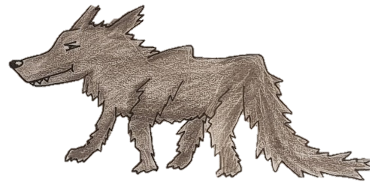

“Movemus, nunc!” Lucius dicit.

Lucius and Julia currunt.

Neptune, God of the Sea, was angry. He was sending an earthquake!

Ambulo – Walks
Oppidum – Town
Templum – Temple
Porto – Holds
Dico – Says
Respondeo – Replies
Quid – What
Clamo – Shouts
Capto – Grabs
Audio – Hear

Video – See
Lupus – Wolf
Canis – Dog
Ara – Altar
Moveo – Move
Nunc – Now
Curro - Run

Write your answer here:

Bonus

If you are feeling keen, here’s a bonus round:

Highlight all the words that are in the accusative case. (Hint: there’s 7)

Answers: (No peeking!)

Lucius walks to town. Julia is in the forum in front of the temple. Julia is holding flowers.

“Hello Julia!” Lucius says.

“Hello, how are you?” Asks Julia.

“Good-“

Lucius was interrupted, suddenly there was a great rumbling sound!

“What is it?” Julia shouts

Lucius grabs a sword. Julia is grey. They hear a wolf. They see a dog under an altar.

“We move, now!” Lucius says.

Lucius and Julia run.

Neptune, God of the Sea, was angry. He was sending an earthquake!

