Welcome Back to Lucius' fundus!

Salve!
Now Lucius is going to tell us how to use verbs in Latin.

Verbs are 'doing words' like, 'I do' or 'he does', and 'I eat' or 'he eats'

So, by the end of this lesson you will be able to say things like:
The horse walks.
He likes.
I watch.
I live.
The dog barks
In Latin!

Esse - To be

Do you remember what Lucius said when you first met him?
sum Lucius
This means 'I am Lucius'
Easy, right? You already knew a Latin verb before we started.
If to say 'I am', Lucius says 'sum', how can he say 'it/she/he is'?
The answer is 'est'.
So, when Lucius sees his pig on his farm, what does he say?
est porcus
This means 'It
is a pig'

Two more verbs!

Latrare = to bark, amare = to like
How do we say ‘I bark’?
First, we take 'latrare' and take away the 'are'. Then we add an 'o'. That gives us 'latro', which means ‘I bark’!
latro!
It's just like maths: latrare - are = latr latr + o = latro, I bark!

1. Can you do the same with amare? How would you say I like? Use the sum below to help you:

Amare – are =
+ o =

Bonus 1
If you like, try to do the same with these verbs too!

Spectare - to watch Vocare - to call
I watch= I call=

Now that we can say 'I like' and 'I bark in Latin, how do we say 'she likes' or 'he barks'?
First, just like for 'I bark' we take away the ‘are’ from ‘latrare’ giving us 'latr'. But now, instead of adding 'o' we add 'at'.
So: latrare - are = latr latr + at = latrat, he barks!

Woof, woof!

Latrat

2. Can you do the same with amare? How would you say I like? Use the sum below to help you:

Amare – are =
+ at =

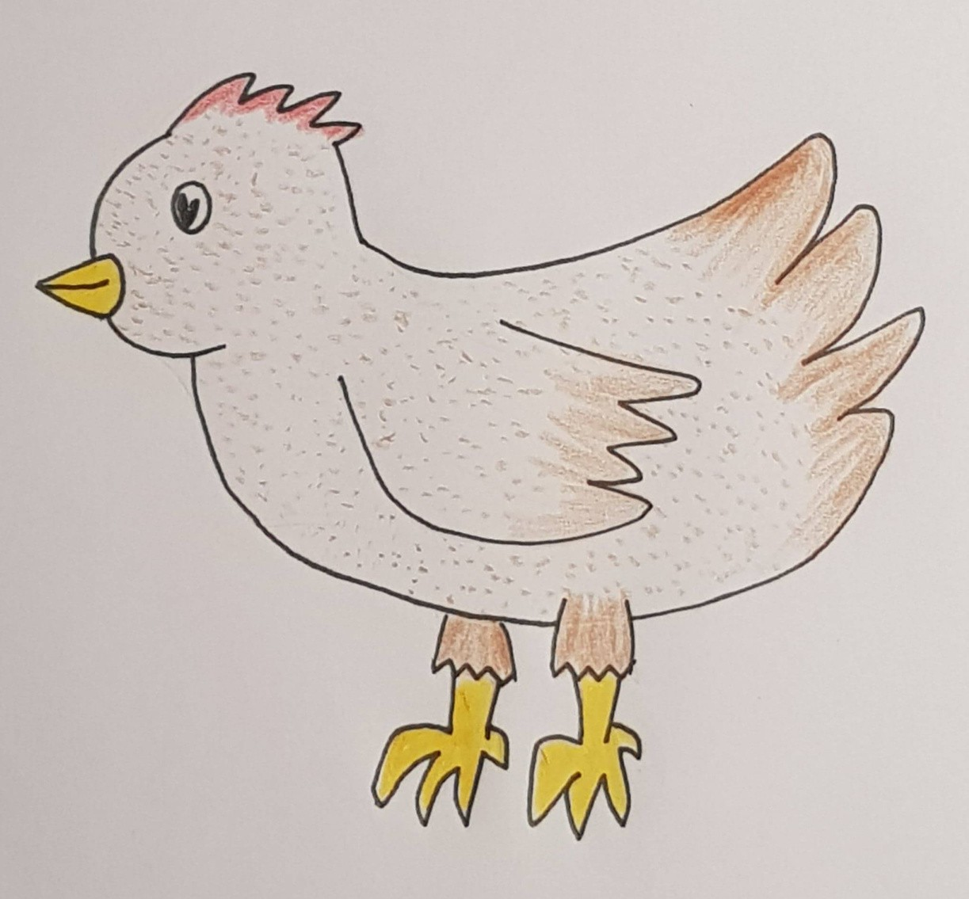
Bonus 2
Want to try with more verbs?
Ambulare – to walk.
He walks=

Habitare - to live
She lives =

Phew that was a lot to learn! Let's try practicing!
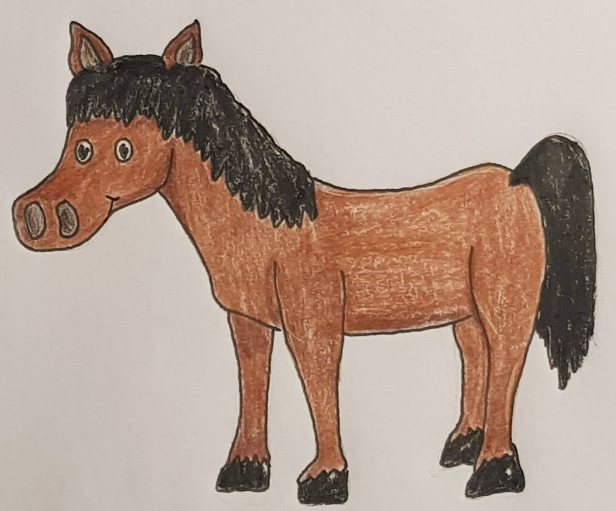
3. I am brown
_ _ _ f_ _ _ _ s

4. The horse walks
_ q _ _ _ _ _ b _ _ _ _

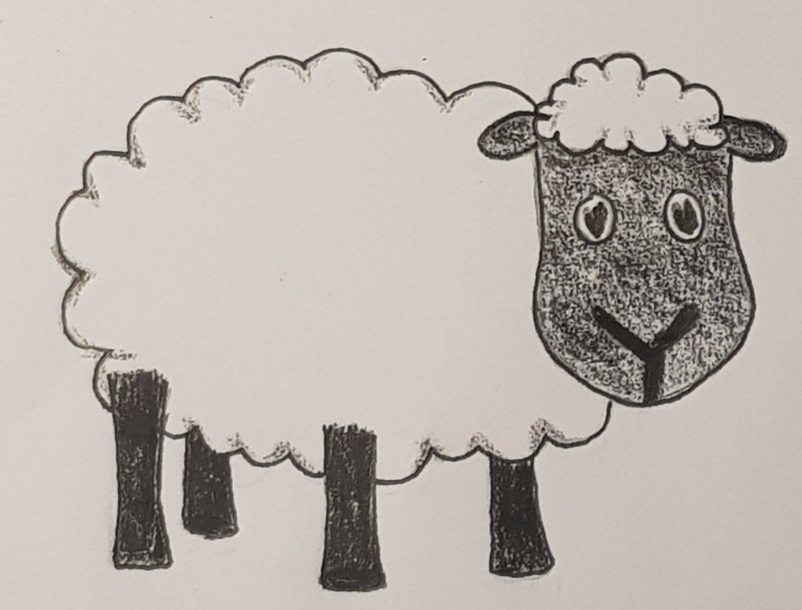
5. I watch
_ _ _ c_ _
6. The sheep is white
O_ _ _ _ _ _ _l_ _ _

7. I live on the farm
_ _ b_ _ _ in fundo
8. Lucius likes animals
_ _ _ _ _ _ m_ _ animales

You can make more sentences by combining two verbs together!

Just like how in English we say 'I like to walk', Latin does the same thing!
'I like to walk' in Latin is therefore 'amo ambulare'

Woof, woof!

Canis amat latrare
The dog likes to bark

Using the verbs you've learnt, see how many other sentences you can create!

Verb Crossword!

 |  |  |  |  |  |  | ▾2
 |  |  |  |  | ▾7
▸5 | ▾4  a |  |  |  |  |  | e
 |  |  |  |  | c
 | b
 |  |  | ▸3 | ▾1 | t
 |  |  |  | m
▸6 |  | t

5. I live 6. He barks 7. She calls

1. She likes
2. I watch
3. I bark
4. It walks

