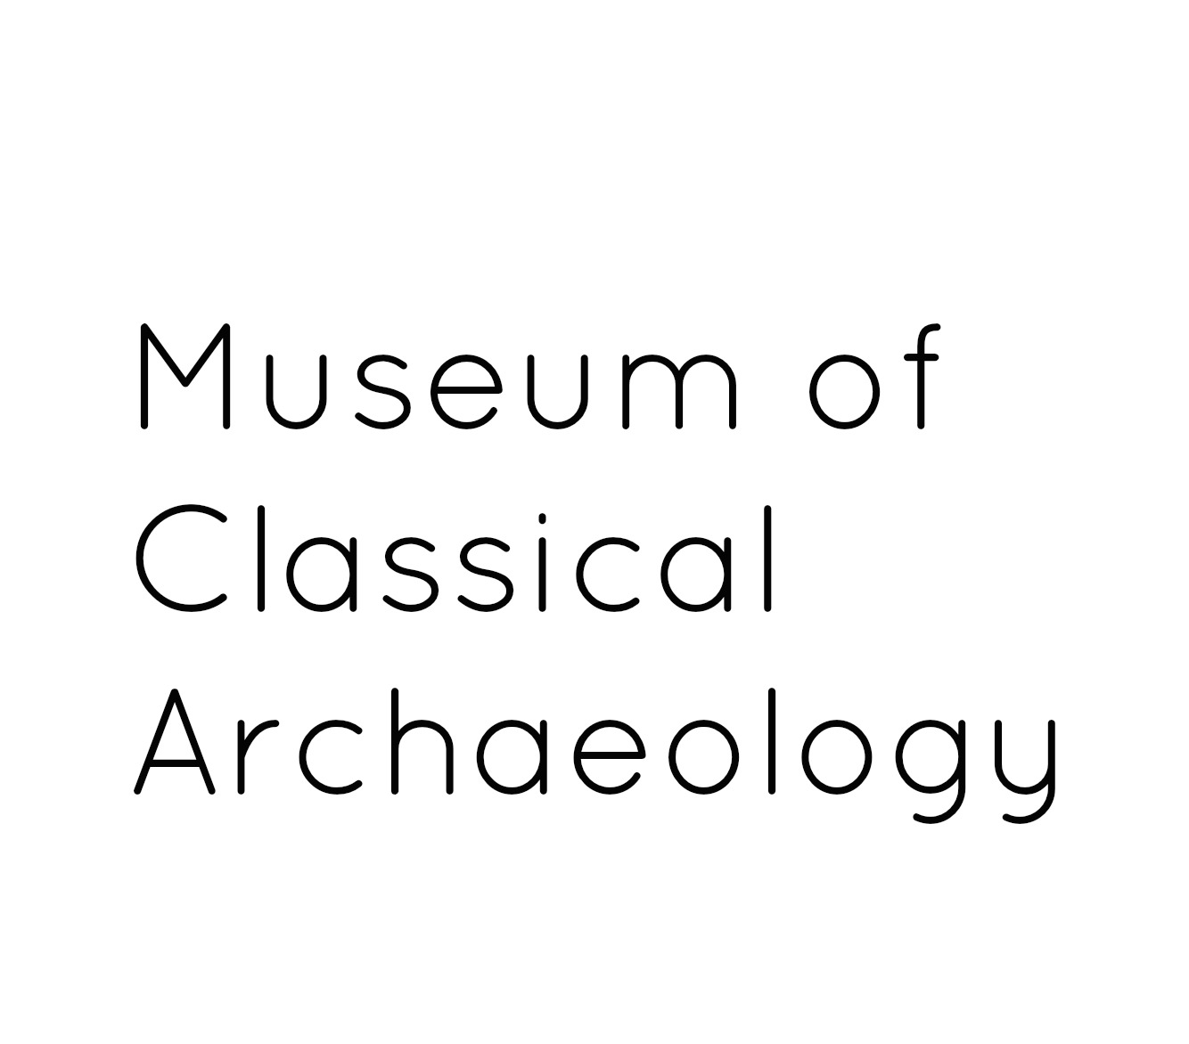

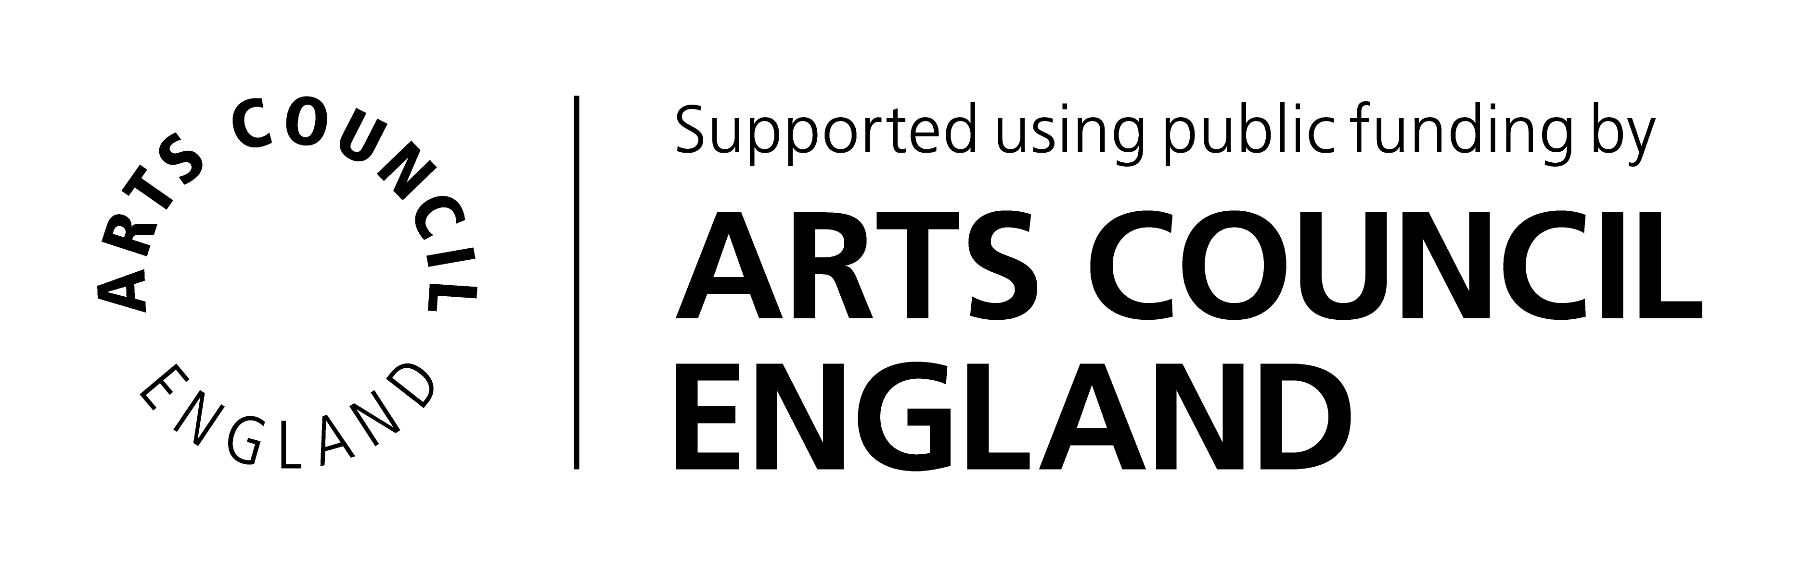

WORK EXPERIENCE EXPRESSION OF INTEREST FORM

Thank you for your interest in undertaking a work experience placement with the University of Cambridge Museums. Please complete this form and return to: Jennie Thornber, Museum Education and Outreach Coordinator, Museum of Classical Archaeology, University of Cambridge, Sidgwick Avenue, Cambridge, CB3 9DA or email to jlt39@cam.ac.uk.

In accordance with The University of Cambridge Child and Vulnerable Adults Safeguarding Policy, our volunteer programme is normally for adults aged 18 or over; this opportunity is available to students at school or university aged 16 or over.

Your contact details

Title (Mr/Miss/Mrs/Ms/Dr/ Other)*
First name(s)*
Surname*
Year of birth*
Home Address* | Postcode:
Email address*
Home telephone number
Mobile telephone number
Preferred method of contact*
School/university you attend*

About you

Please tell us why you would like to undertake a placement at the Museum of Classical Archaeology and Classical Faculty Library:*

How did you hear about volunteering with us?*

Special Requirements
If you require any special arrangements to be made or if you have any medical conditions you’d like us to be aware of, please specify those below. This information is requested so that we may care for your needs and will be kept confidential.*

Availability

Work experience placements will be offered in the period 29th July-30th August 2019. Please indicate if you have any preference for dates or if there are dates which would not be possible for you.*

Emergency Contact Details

Please give details of your next of kin to contact in case of emergency.

Name*
Address | Postcode:
Email address*
Daytime tel. number*

Referees
Please give contact details of two people (other than relatives or partners) who have known you for more than 2 years who we can contact to comment on your suitability to volunteer for us.

Referee 1  Name* |  | Referee 2  Name*
Relationship to you* |  | Relationship to you*
Address | Postcode: | Address | Postcode:
Email address* |  | Email address*
Telephone |  | Telephone

Please be sure to complete all sections marked with an *.
Your personal information provided on this form will be kept in accordance with the Data Protection Act 1998/2003 (as amended from time to time). Your information will be held securely and accessed only by authorised persons, which shall include our funders Arts Council England. Anonymised aspects of the information given by you may be used for statistical purposes.

I am over 16 years old and I declare that the information I have provided is true:

Signed ........................................................................................... Date ...............................

How the University of Cambridge Museums uses your personal information
The University of Cambridge Museums uses your personal information to contact you about volunteer roles or projects that you have applied for and other related activities.
We use your personal information in order to deliver our contractual obligations to you as a user of our service. More information about our work can be found on our website https://www.museums.cam.ac.uk/
For more information about how we handle your personal information, and your rights under data protection legislation, please see https://www.information-compliance.admin.cam.ac.uk/data-protection/general-data.

